Transmission Timings Report Week - 6
2/02/2026 - 8/02/2026

SBR2 External Vendor Testing Environment (EVTE3)

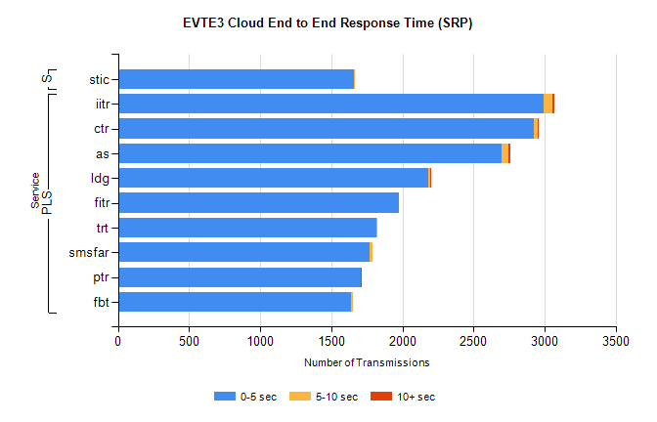
Stream | Service | 0-5 sec | 5-10 sec | >10 sec | Total | % within 5 sec timing target
PLS | iitr | 2990 | 64 | 13 | 3099 | 96.5%
PLS | ctr | 2924 | 25 | 1 | 3006 | 97.3%
PLS | as | 2699 | 47 | 12 | 2891 | 93.4%
PLS | ldg | 2183 | 12 | 3 | 2212 | 98.7%
PLS | fitr | 1976 | 0 | 0 | 1982 | 99.7%
PLS | trt | 1817 | 4 | 0 | 1825 | 99.6%
PLS | smsfar | 1771 | 20 | 0 | 1791 | 98.9%
PLS | ptr | 1707 | 1 | 1 | 1723 | 99.1%
PLS | fbt | 1640 | 11 | 0 | 1652 | 99.3%
Super | stic | 1659 | 1 | 0 | 1660 | 99.9%

SBR2 External Vendor Testing Environment (EVTE3)

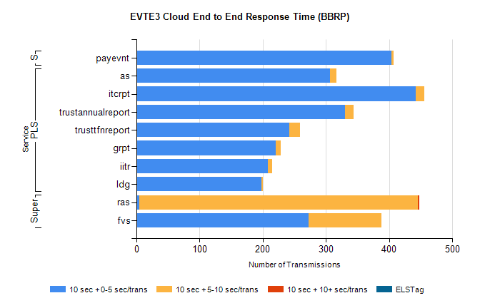
Stream | Service | 10 sec + 0-5 sec /trans | 10 sec + 5-10 sec /trans | 10 sec + >10 sec /trans | Processing Incomplete | ELStag | Total
PLS | as | 306 | 10 | 0 | 302 | 0 | 618
PLS | itcrpt | 442 | 14 | 0 | 8 | 0 | 464
PLS | trustannualreport | 330 | 14 | 0 | 0 | 0 | 344
PLS | trusttfnreport | 242 | 17 | 0 | 0 | 0 | 259
PLS | grpt | 221 | 7 | 0 | 4 | 0 | 232
PLS | iitr | 208 | 7 | 0 | 0 | 0 | 221
PLS | ldg | 198 | 2 | 0 | 11 | 0 | 213
Super | ras | 4 | 442 | 2 | 0 | 0 | 459
Super | fvs | 272 | 116 | 0 | 20 | 0 | 410
STP | payevnt | 404 | 3 | 0 | 57 | 0 | 464

SBR2 External Vendor Testing Environment (EVTE3)

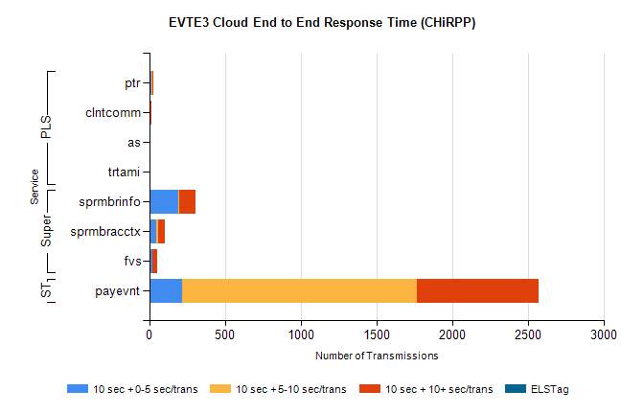
Stream | Service | 10 sec + 0-5 sec /trans | 10 sec + 5-10 sec /trans | 10 sec + >10 sec /trans | Total | % within 5 sec timing target
STP | payevnt | 215 | 1554 | 805 | 3760 | 5.7%
Super | sprmbrinfo | 190 | 9 | 106 | 330 | 57.8%
Super | sprmbracctx | 45 | 11 | 48 | 123 | 36.6%
Super | fvs | 20 | 0 | 35 | 103 | 19.4%
PLS | ptr | 16 | 2 | 3 | 22 | 72.7%
PLS | clntcomm | 0 | 0 | 17 | 17 | 0.0%
PLS | as | 0 | 0 | 7 | 7 | 0.0%
PLS | trtami | 0 | 0 | 6 | 6 | 0.0%

