Transmission Timings Report Week - 6
2/02/2026 - 8/02/2026

SBR2 Cloud Production2 - Single | Bulk or Batch Requests | (SRP, BBRP & CHiRPP)

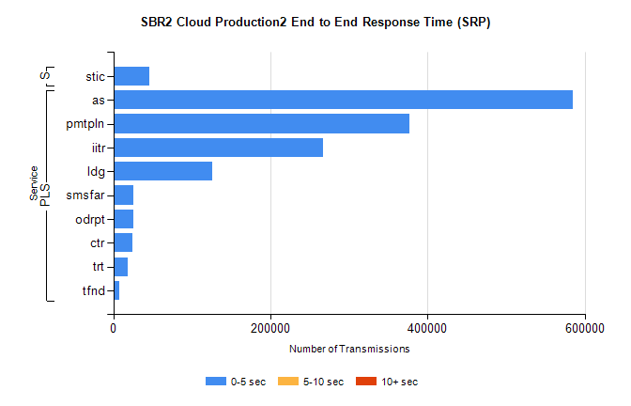
Stream | Service | 0-5 sec | 5-10 sec | >10 sec | Total | % within 5 sec timing target
PLS | as | 584433 | 0 | 0 | 584433 | 100.0%
PLS | pmtpln | 376646 | 0 | 0 | 376646 | 100.0%
PLS | iitr | 267285 | 0 | 0 | 267285 | 100.0%
PLS | ldg | 126044 | 0 | 0 | 126044 | 100.0%
PLS | smsfar | 25679 | 0 | 0 | 25679 | 100.0%
PLS | odrpt | 25663 | 0 | 0 | 25663 | 100.0%
PLS | ctr | 24014 | 0 | 0 | 24014 | 100.0%
PLS | trt | 18796 | 0 | 0 | 18796 | 100.0%
PLS | tfnd | 8074 | 0 | 0 | 8074 | 100.0%
Super | stic | 45456 | 0 | 0 | 45456 | 100.0%

SBR2 Cloud Production2 - Single | Bulk or Batch Requests | (SRP, BBRP & CHiRPP)

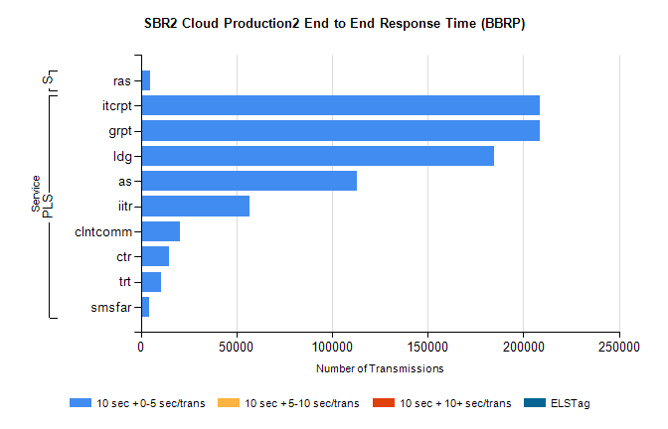
Stream | Service | 10 sec + 0-5 sec /trans | 10 sec + 5-10 sec /trans | 10 sec + >10 sec /trans | Processing Incomplete | ELStag | Total
PLS | grpt | 208400 | 0 | 0 | 0 | 0 | 208400
PLS | itcrpt | 208400 | 0 | 0 | 0 | 0 | 208400
PLS | ldg | 184471 | 0 | 0 | 0 | 0 | 184471
PLS | as | 112991 | 0 | 0 | 0 | 0 | 112991
PLS | iitr | 56801 | 0 | 0 | 0 | 0 | 56801
PLS | clntcomm | 20373 | 0 | 0 | 0 | 0 | 20373
PLS | ctr | 14609 | 0 | 0 | 0 | 0 | 14609
PLS | trt | 10616 | 0 | 0 | 0 | 0 | 10616
PLS | smsfar | 4418 | 0 | 0 | 0 | 0 | 4418
Super | ras | 4960 | 0 | 0 | 0 | 0 | 4960

SBR2 Cloud Production2 - Single | Bulk or Batch Requests | (SRP, BBRP & CHiRPP)

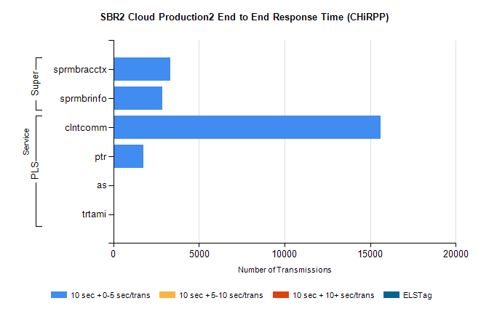
Stream | Service | 10 sec + 0-5 sec /trans | 10 sec + 5-10 sec /trans | 10 sec + >10 sec /trans | Total | % within 5 sec timing target
PLS | clntcomm | 15598 | 0 | 0 | 15598 | 100.0%
PLS | ptr | 1737 | 0 | 0 | 1737 | 100.0%
PLS | as | 38 | 0 | 0 | 38 | 100.0%
PLS | trtami | 17 | 0 | 0 | 17 | 100.0%
Super | sprmbracctx | 3304 | 0 | 0 | 3304 | 100.0%
Super | sprmbrinfo | 2840 | 0 | 0 | 2840 | 100.0%

SBR1 Production Transactions

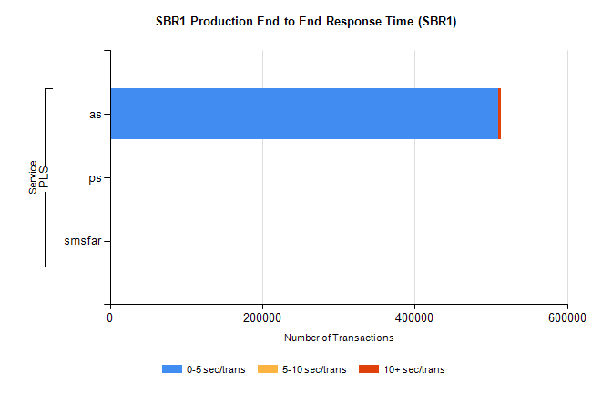
Stream | Service | 0-5 sec/trans | 5-10 sec/trans | 10+ sec/trans | Total | % within 5 sec timing target
PLS | as | 509328 | 752 | 2845 | 512925 | 99.3%
PLS | ps | 272 | 10 | 65 | 347 | 78.4%
PLS | smsfar | 2 | 6 |  | 8 | 25.0%

