Transmission Timings Report Week - 7
9/02/2026 - 15/02/2026

SBR2 External Vendor Testing Environment (EVTE3)

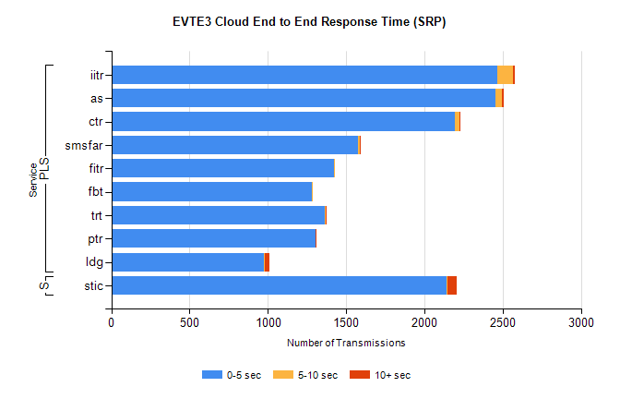
Stream | Service | 0-5 sec | 5-10 sec | >10 sec | Total | % within 5 sec timing target
PLS | iitr | 2465 | 102 | 13 | 2580 | 95.5%
PLS | as | 2456 | 40 | 8 | 2534 | 96.9%
PLS | ctr | 2194 | 30 | 5 | 2234 | 98.2%
PLS | smsfar | 1576 | 9 | 1 | 1587 | 99.3%
PLS | fitr | 1420 | 1 | 0 | 1423 | 99.8%
PLS | fbt | 1284 | 4 | 0 | 1398 | 91.8%
PLS | trt | 1362 | 5 | 3 | 1374 | 99.1%
PLS | ptr | 1303 | 2 | 5 | 1313 | 99.2%
PLS | ldg | 972 | 10 | 30 | 1014 | 95.9%
Super | stic | 2144 | 4 | 61 | 2209 | 97.1%

SBR2 External Vendor Testing Environment (EVTE3)

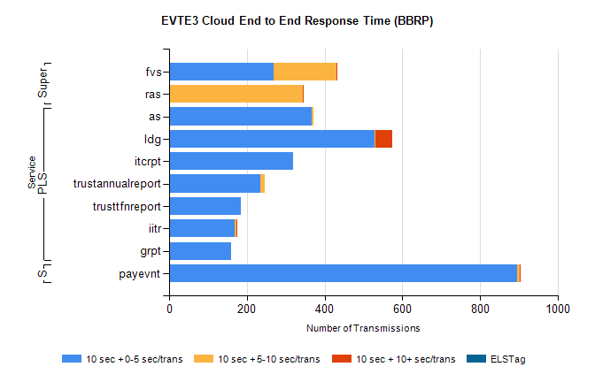
Stream | Service | 10 sec + 0-5 sec /trans | 10 sec + 5-10 sec /trans | 10 sec + >10 sec /trans | Processing Incomplete | ELStag | Total
PLS | as | 366 | 5 | 0 | 341 | 0 | 713
PLS | ldg | 529 | 1 | 44 | 53 | 0 | 628
PLS | itcrpt | 320 | 0 | 0 | 0 | 0 | 320
PLS | trustannualreport | 234 | 11 | 0 | 0 | 0 | 245
PLS | trusttfnreport | 185 | 0 | 0 | 0 | 0 | 185
PLS | iitr | 169 | 4 | 2 | 3 | 0 | 182
PLS | grpt | 160 | 0 | 0 | 0 | 0 | 160
STP | payevnt | 896 | 6 | 4 | 38 | 0 | 944
Super | fvs | 270 | 161 | 3 | 8 | 0 | 446
Super | ras | 0 | 343 | 4 | 0 | 0 | 351

SBR2 External Vendor Testing Environment (EVTE3)

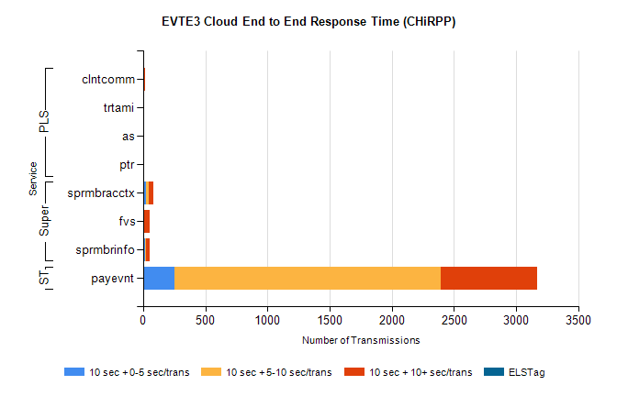
Stream | Service | 10 sec + 0-5 sec /trans | 10 sec + 5-10 sec /trans | 10 sec + >10 sec /trans | Total | % within 5 sec timing target
STP | payevnt | 254 | 2143 | 770 | 4321 | 5.9%
Super | sprmbracctx | 23 | 25 | 33 | 103 | 22.3%
Super | fvs | 2 | 0 | 48 | 69 | 2.9%
Super | sprmbrinfo | 18 | 5 | 28 | 60 | 30.0%
PLS | clntcomm | 0 | 0 | 19 | 21 | 0.0%
PLS | as | 0 | 0 | 12 | 12 | 0.0%
PLS | trtami | 0 | 0 | 12 | 12 | 0.0%
PLS | ptr | 0 | 0 | 3 | 3 | 0.0%

