Transmission Timings Report Week - 7
9/02/2026 - 15/02/2026

SBR2 Cloud Production2 - Single | Bulk or Batch Requests | (SRP, BBRP & CHiRPP)

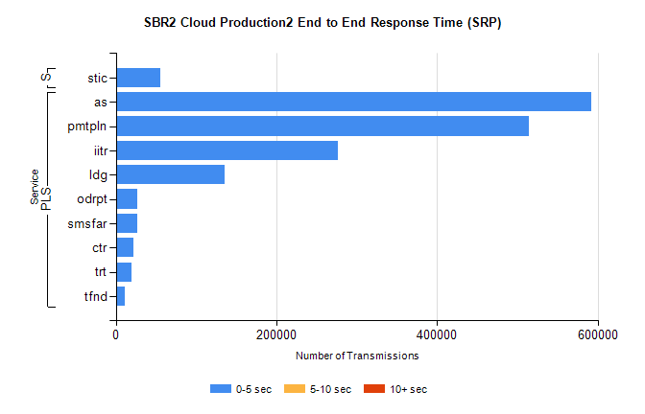
Stream | Service | 0-5 sec | 5-10 sec | >10 sec | Total | % within 5 sec timing target
PLS | as | 592121 | 0 | 0 | 592121 | 100.0%
PLS | pmtpln | 514118 | 0 | 0 | 514118 | 100.0%
PLS | iitr | 276950 | 0 | 0 | 276950 | 100.0%
PLS | ldg | 135388 | 0 | 0 | 135388 | 100.0%
PLS | odrpt | 26856 | 0 | 0 | 26856 | 100.0%
PLS | smsfar | 26249 | 0 | 0 | 26249 | 100.0%
PLS | ctr | 22427 | 0 | 0 | 22427 | 100.0%
PLS | trt | 19820 | 0 | 0 | 19820 | 100.0%
PLS | tfnd | 11606 | 0 | 0 | 11606 | 100.0%
Super | stic | 55759 | 0 | 0 | 55759 | 100.0%

SBR2 Cloud Production2 - Single | Bulk or Batch Requests | (SRP, BBRP & CHiRPP)

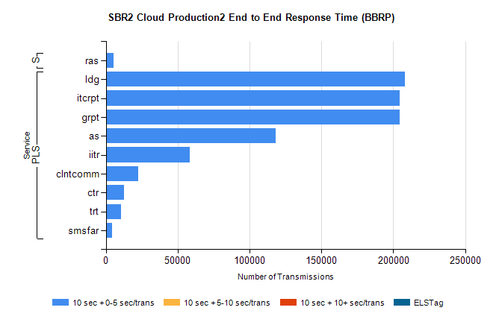
Stream | Service | 10 sec + 0-5 sec /trans | 10 sec + 5-10 sec /trans | 10 sec + >10 sec /trans | Processing Incomplete | ELStag | Total
PLS | ldg | 207987 | 0 | 0 | 0 | 0 | 207987
PLS | grpt | 204227 | 0 | 0 | 0 | 0 | 204227
PLS | itcrpt | 204227 | 0 | 0 | 0 | 0 | 204227
PLS | as | 117968 | 0 | 0 | 0 | 0 | 117968
PLS | iitr | 58331 | 0 | 0 | 0 | 0 | 58331
PLS | clntcomm | 22697 | 0 | 0 | 0 | 0 | 22697
PLS | ctr | 12592 | 0 | 0 | 0 | 0 | 12592
PLS | trt | 10669 | 0 | 0 | 0 | 0 | 10669
PLS | smsfar | 4439 | 0 | 0 | 0 | 0 | 4439
Super | ras | 5288 | 0 | 0 | 0 | 0 | 5288

SBR2 Cloud Production2 - Single | Bulk or Batch Requests | (SRP, BBRP & CHiRPP)

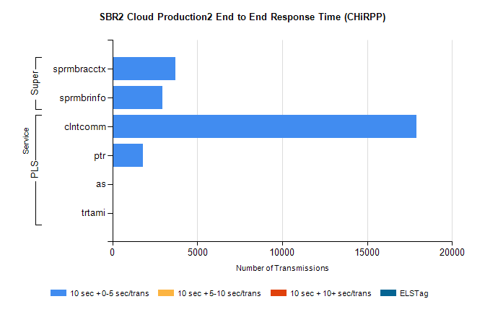
Stream | Service | 10 sec + 0-5 sec /trans | 10 sec + 5-10 sec /trans | 10 sec + >10 sec /trans | Total | % within 5 sec timing target
PLS | clntcomm | 17915 | 0 | 0 | 17915 | 100.0%
PLS | ptr | 1786 | 0 | 0 | 1786 | 100.0%
PLS | as | 37 | 0 | 0 | 37 | 100.0%
PLS | trtami | 15 | 0 | 0 | 15 | 100.0%
Super | sprmbracctx | 3691 | 0 | 0 | 3691 | 100.0%
Super | sprmbrinfo | 2937 | 0 | 0 | 2937 | 100.0%

SBR1 Production Transactions

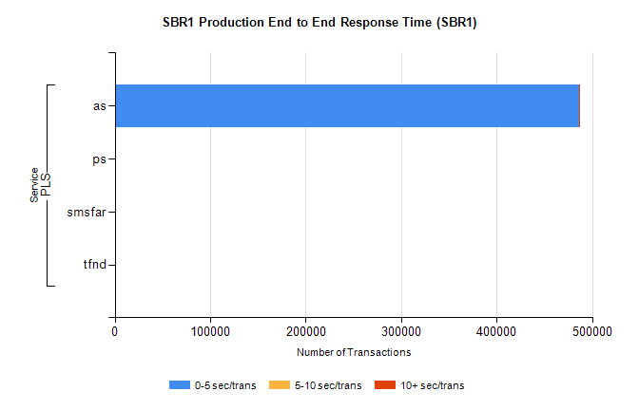
Stream | Service | 0-5 sec/trans | 5-10 sec/trans | 10+ sec/trans | Total | % within 5 sec timing target
PLS | as | 486294 | 252 | 297 | 486843 | 99.9%
PLS | ps | 262 | 10 | 83 | 355 | 73.8%
PLS | smsfar | 5 | 11 |  | 16 | 31.3%
PLS | tfnd | 10 |  |  | 10 | 100.0%

