Transmission Timings Report Week - 8
16/02/2026 - 22/02/2026

SBR2 External Vendor Testing Environment (EVTE3)

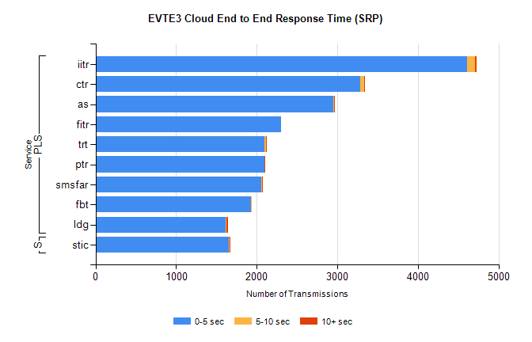
Stream | Service | 0-5 sec | 5-10 sec | >10 sec | Total | % within 5 sec timing target
PLS | iitr | 4606 | 104 | 22 | 4738 | 97.2%
PLS | ctr | 3286 | 47 | 2 | 3370 | 97.5%
PLS | as | 2947 | 12 | 15 | 3042 | 96.9%
PLS | fitr | 2298 | 0 | 0 | 2298 | 100.0%
PLS | trt | 2100 | 11 | 1 | 2124 | 98.9%
PLS | ptr | 2095 | 3 | 1 | 2116 | 99.0%
PLS | smsfar | 2054 | 13 | 8 | 2075 | 99.0%
PLS | fbt | 1929 | 5 | 0 | 1952 | 98.8%
PLS | ldg | 1610 | 12 | 20 | 1674 | 96.2%
Super | stic | 1657 | 6 | 15 | 1678 | 98.7%

SBR2 External Vendor Testing Environment (EVTE3)

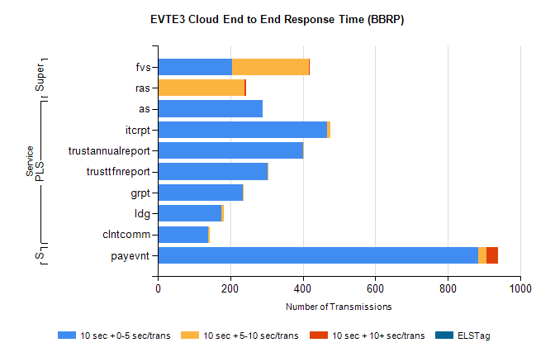
Stream | Service | 10 sec + 0-5 sec /trans | 10 sec + 5-10 sec /trans | 10 sec + >10 sec /trans | Processing Incomplete | ELStag | Total
PLS | as | 290 | 0 | 0 | 266 | 0 | 557
PLS | itcrpt | 468 | 8 | 0 | 0 | 0 | 476
PLS | trustannualreport | 400 | 2 | 0 | 0 | 0 | 402
PLS | trusttfnreport | 303 | 3 | 0 | 0 | 0 | 306
PLS | grpt | 234 | 4 | 0 | 0 | 0 | 238
PLS | ldg | 175 | 8 | 0 | 18 | 0 | 201
PLS | clntcomm | 139 | 4 | 0 | 28 | 0 | 171
STP | payevnt | 885 | 22 | 33 | 37 | 0 | 992
Super | fvs | 204 | 212 | 4 | 6 | 0 | 431
Super | ras | 0 | 240 | 3 | 0 | 0 | 255

SBR2 External Vendor Testing Environment (EVTE3)

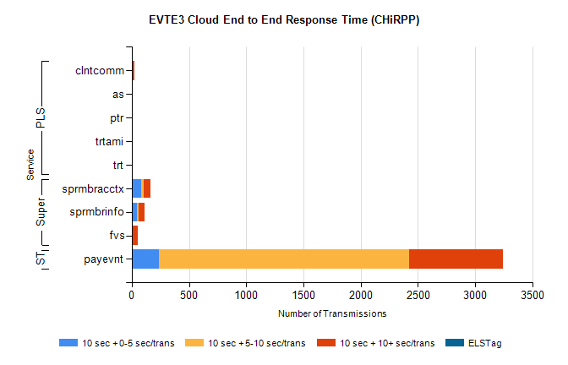
Stream | Service | 10 sec + 0-5 sec /trans | 10 sec + 5-10 sec /trans | 10 sec + >10 sec /trans | Total | % within 5 sec timing target
STP | payevnt | 241 | 2183 | 819 | 4493 | 5.4%
Super | sprmbracctx | 84 | 23 | 54 | 188 | 44.7%
Super | sprmbrinfo | 44 | 15 | 55 | 123 | 35.8%
Super | fvs | 3 | 0 | 48 | 77 | 3.9%
PLS | clntcomm | 2 | 0 | 23 | 30 | 6.7%
PLS | as | 0 | 1 | 6 | 9 | 0.0%
PLS | trtami | 0 | 0 | 2 | 2 | 0.0%
PLS | ptr | 0 | 0 | 2 | 2 | 0.0%
PLS | trt | 0 | 0 | 1 | 1 | 0.0%

