Transmission Timings Report Week - 8
16/02/2026 - 22/02/2026

SBR2 Cloud Production2 - Single | Bulk or Batch Requests | (SRP, BBRP & CHiRPP)

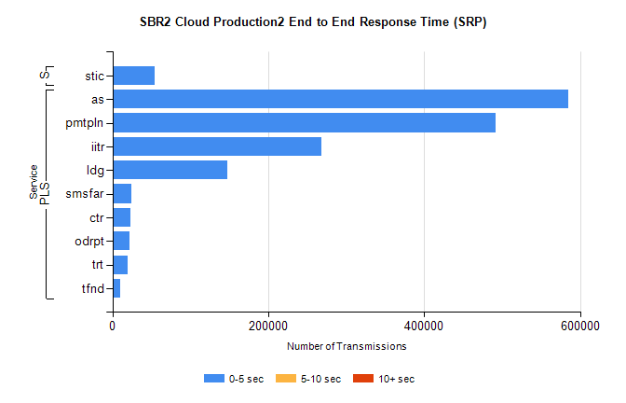
Stream | Service | 0-5 sec | 5-10 sec | >10 sec | Total | % within 5 sec timing target
PLS | as | 585333 | 0 | 0 | 585333 | 100.0%
PLS | pmtpln | 492091 | 0 | 0 | 492091 | 100.0%
PLS | iitr | 268607 | 0 | 0 | 268607 | 100.0%
PLS | ldg | 147786 | 0 | 0 | 147786 | 100.0%
PLS | smsfar | 24669 | 0 | 0 | 24669 | 100.0%
PLS | ctr | 23106 | 0 | 0 | 23106 | 100.0%
PLS | odrpt | 22325 | 0 | 0 | 22325 | 100.0%
PLS | trt | 19693 | 0 | 0 | 19693 | 100.0%
PLS | tfnd | 9595 | 0 | 0 | 9595 | 100.0%
Super | stic | 54201 | 0 | 0 | 54201 | 100.0%

SBR2 Cloud Production2 - Single | Bulk or Batch Requests | (SRP, BBRP & CHiRPP)

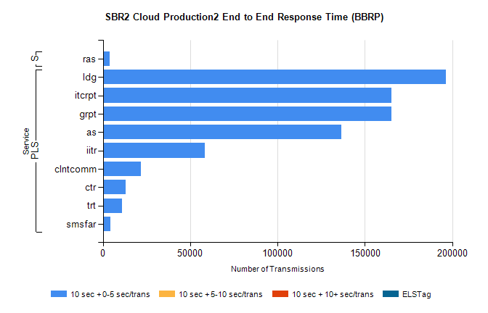
Stream | Service | 10 sec + 0-5 sec /trans | 10 sec + 5-10 sec /trans | 10 sec + >10 sec /trans | Processing Incomplete | ELStag | Total
PLS | ldg | 196244 | 0 | 0 | 0 | 0 | 196244
PLS | grpt | 165396 | 0 | 0 | 0 | 0 | 165396
PLS | itcrpt | 165396 | 0 | 0 | 0 | 0 | 165396
PLS | as | 136712 | 0 | 0 | 0 | 0 | 136712
PLS | iitr | 58440 | 0 | 0 | 0 | 0 | 58440
PLS | clntcomm | 21712 | 0 | 0 | 0 | 0 | 21712
PLS | ctr | 13043 | 0 | 0 | 0 | 0 | 13043
PLS | trt | 10905 | 0 | 0 | 0 | 0 | 10905
PLS | smsfar | 4388 | 0 | 0 | 0 | 0 | 4388
Super | ras | 3991 | 0 | 0 | 0 | 0 | 3991

SBR2 Cloud Production2 - Single | Bulk or Batch Requests | (SRP, BBRP & CHiRPP)

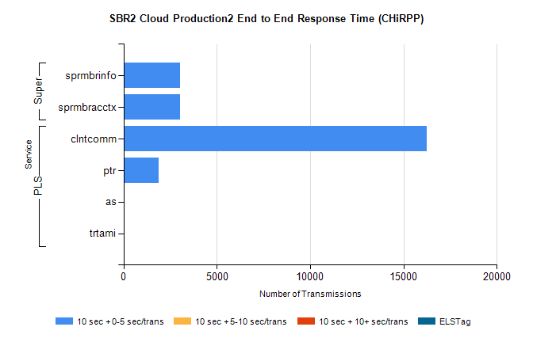
Stream | Service | 10 sec + 0-5 sec /trans | 10 sec + 5-10 sec /trans | 10 sec + >10 sec /trans | Total | % within 5 sec timing target
PLS | clntcomm | 16246 | 0 | 0 | 16246 | 100.0%
PLS | ptr | 1863 | 0 | 0 | 1863 | 100.0%
PLS | as | 56 | 0 | 0 | 56 | 100.0%
PLS | trtami | 26 | 0 | 0 | 26 | 100.0%
Super | sprmbrinfo | 3019 | 0 | 0 | 3019 | 100.0%
Super | sprmbracctx | 3008 | 0 | 0 | 3008 | 100.0%

SBR1 Production Transactions

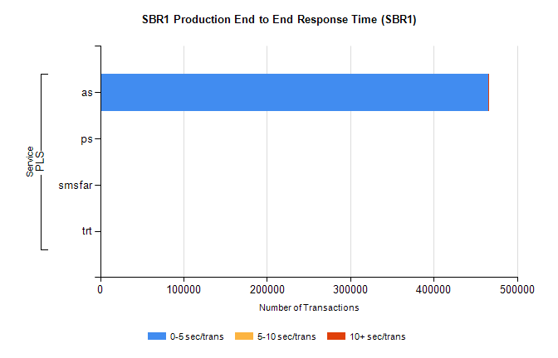
Stream | Service | 0-5 sec/trans | 5-10 sec/trans | 10+ sec/trans | Total | % within 5 sec timing target
PLS | as | 465540 | 157 | 332 | 466029 | 99.9%
PLS | ps | 18 | 21 | 100 | 139 | 12.9%
PLS | smsfar |  | 5 |  | 5 | 0.0%
PLS | trt |  |  | 1 | 1 | 0.0%

