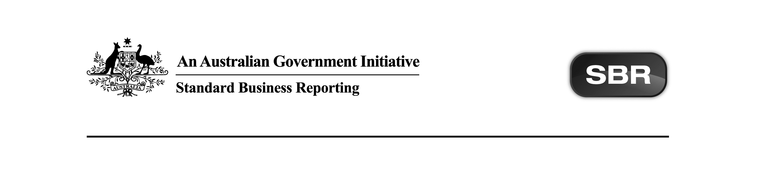
Contribution standard v3.0
Australian Taxation Office

Technical artefacts Package Content Note

Date: 13 March 2026

This document and its attachments are Official | For further information or questions, raise a ticket via the DSP service desk or contact DPO@ato.gov.au

VERSION CONTROL

Version | Release date | Description of changes
1.1 | 12.03.2026 | Additional changes to sample messages and schematron files. Detailed information in section 2.1
1 | 06.03.2026 | Added information on the changes to the sample messages and schematron.

Note: Previous Version history can be found in Appendix A of this document.

Copyright
© Commonwealth of Australia 2026 (see exceptions below).
This work is copyright. Use of this Information and Material is subject to the terms and conditions in the "DSP Conditions of Use" which is available at https://softwaredevelopers.ato.gov.au. You must ensure that you comply with those terms and conditions. In particular, those terms and conditions include disclaimers and limitations on the liability of the Commonwealth and an indemnity from you to the Commonwealth and its personnel and their personnel.
You must include this copyright notice in all copies of this Information and Material which you create. If you modify, adapt or prepare derivative works of the Information and Material, the notice must still be included but you must add your own copyright statement to your modification, adaptation or derivative work which makes clear the nature of your modification, adaptation or derivative work and you must include an acknowledgement that the adaptation, modification or derivative work is based on Commonwealth or Agency owned Information and Material.

Table of contents
1 Introduction 5
1.1 Document purpose 5
1.2 Audience 5
1.3 Purpose of this package 5
1.4 Summary of artefacts within ATO packages 5
1.4.1 In general 5
1.4.2 Services 6
1.4.3 Interactions 6
1.4.4 Package artefact status description 6
2 Package contents 7
2.1 Service Artefacts 7
2.2 External 9
3 C# changes 10
3.1 Technical changes 10
3.2 Event message changes 10
4 Known issues and future scope 11
4.1 Issues and incidents 11
4.2 Future changes 11
Appendix A – Prior Version History 12

Introduction

Document purpose
The purpose of this Package Content Note (PCN) is to advise software developers of the package contents for the Contributions standard v3.0 technical artefacts provided by the Australian Taxation Office (ATO).

Audience
The audience for this Package Content Note is software developers who have or are interested in developing Contributions standard v3.0.

Purpose of this package
The purpose of this package is to streamline the way message artefacts are presented to software developers.

All relevant technical artefacts that comprise the Contributions standard v3.0 suite are available on Contribution standard v3.0 | ATO Software Developers. The package will be versioned up each time artefacts are added or updated.

The first PCN released outlines the expected artefacts to be within the package at an end state – as known at that point in time.

.

Services
The following table shows the services that form the Contributions product suite and their relationship to previous versions:
Description | Change | Comments
Contributions v3.0 Schematron | Updated

Technical artefacts
The following table lists the interactions for a given service within this package.
Description | Change | Comments
Contributions v3.0 schematron | Updated
SuperStream 3.0 Sample Messages | Updated
Schedule 2 Terms and definitions v3.0-0.1 | Present
Schedule 3 Payment Methods v3.1 | Present
Schedule 4a Contributions MIG v3.0-0.4 | Present
Schedule 5 Orchestration and profiles v3.0-0.1 | Present
Schedule 6 Error code management v3.0-0.4 | Present
G051 – SuperStream payments using NPP | Present
Detailed information on each service can be found in the Service Registry, along with associated messages.

Package contents
  - Technical Artefact changes

The table below outlines changes to the package contents.
Name | Update Date | Document Status | Comments
SuperStream 3.0 Sample Messages | 12.03.2026 | Final | - Removed duplicate references to PersonDemographicDetails.Sex.Code in the Member Registration Request 3.0 Request Sample  - Split the Member Verification Request 3.0 Request Sample into 2 separate samples, the first for a non-USI request, and the second for a USI request  - Removed duplicate references to PersonDemographicDetails.Sex.Code in the Member Verification Request 3.0 Request Samples
Contributions v3.0 Schematron | 12.03.2026 | Final | - Updated code for Member Verification Request to allow the SuperFundUniqueSuperannuationIdentifierDimension

Total artefacts in this Package: | 8
Present artefacts | 8
New artefacts | 6
Updated artefacts | 2
Pending artefacts | 0
Removed artefacts | 0

- Known issues and future scope
The following is a list of issues and/or future work to be implemented. There may be impacts to successful development until the issues are resolved or the future scope has been implemented (as an example where a service is deployed over multiple iterations and won’t be complete for some time).

Issues and incidents
Issue  # | Issue Description | Impacted  Interactions | Incident Number | Resolution | Proposed  EVTE Date | Proposed  PROD Date | Issue Status (Open/  Closed)
N/A

Future changes
Change  # | Change Description | Impacted  Interactions | Proposed  EVTE Date | Proposed  PROD Date | Change Status (Open/  Closed)
N/A

Appendix A – Prior Version History
Version | Release date | Description of changes
1.0 | 06.03.2026 | First version of PCN

