Transmission Timings Report Week - 10
2/03/2026 - 8/03/2026

SBR2 External Vendor Testing Environment (EVTE3)

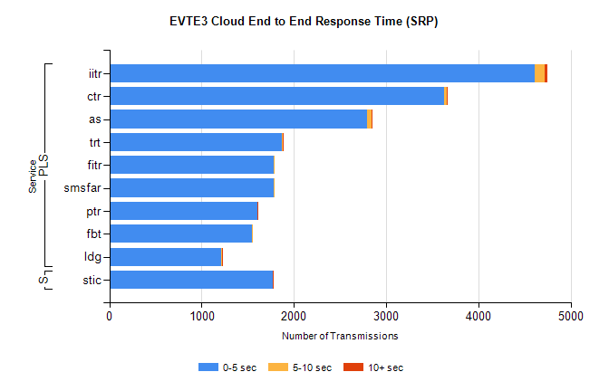
Stream | Service | 0-5 sec | 5-10 sec | >10 sec | Total | % within 5 sec timing target
PLS | iitr | 4614 | 105 | 28 | 4747 | 97.2%
PLS | ctr | 3626 | 33 | 4 | 3684 | 98.4%
PLS | as | 2789 | 55 | 3 | 2966 | 94.0%
PLS | trt | 1874 | 1 | 1 | 1890 | 99.2%
PLS | fitr | 1781 | 2 | 0 | 1824 | 97.6%
PLS | smsfar | 1779 | 7 | 0 | 1786 | 99.6%
PLS | ptr | 1600 | 5 | 2 | 1623 | 98.6%
PLS | fbt | 1545 | 8 | 0 | 1606 | 96.2%
PLS | ldg | 1213 | 7 | 3 | 1232 | 98.5%
Super | stic | 1770 | 6 | 1 | 1777 | 99.6%

SBR2 External Vendor Testing Environment (EVTE3)

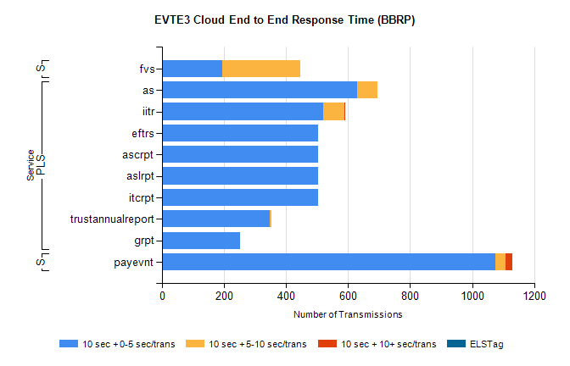
Stream | Service | 10 sec + 0-5 sec /trans | 10 sec + 5-10 sec /trans | 10 sec + >10 sec /trans | Processing Incomplete | ELStag | Total
PLS | as | 629 | 67 | 0 | 307 | 0 | 1005
PLS | iitr | 521 | 67 | 3 | 45 | 0 | 647
PLS | itcrpt | 502 | 0 | 0 | 72 | 0 | 574
PLS | aslrpt | 502 | 0 | 0 | 72 | 0 | 574
PLS | ascrpt | 502 | 0 | 0 | 72 | 0 | 574
PLS | eftrs | 502 | 0 | 0 | 72 | 0 | 574
PLS | trustannualreport | 348 | 4 | 0 | 0 | 0 | 352
PLS | grpt | 251 | 0 | 0 | 36 | 0 | 287
STP | payevnt | 1076 | 33 | 20 | 46 | 0 | 1188
Super | fvs | 194 | 253 | 0 | 17 | 0 | 467

SBR2 External Vendor Testing Environment (EVTE3)

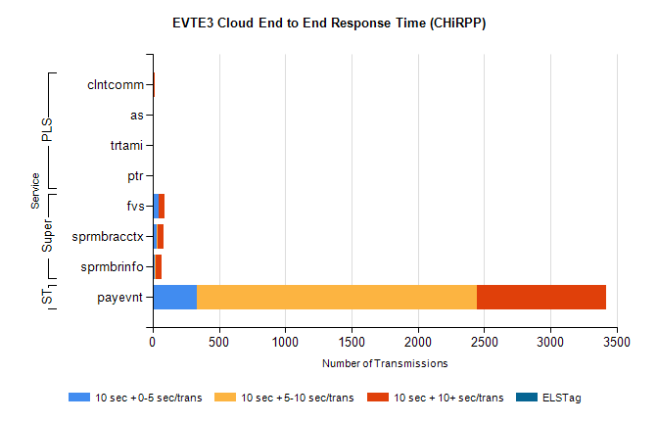
Stream | Service | 10 sec + 0-5 sec /trans | 10 sec + 5-10 sec /trans | 10 sec + >10 sec /trans | Total | % within 5 sec timing target
STP | payevnt | 336 | 2111 | 971 | 4895 | 6.9%
Super | fvs | 44 | 0 | 49 | 142 | 31.0%
Super | sprmbracctx | 30 | 10 | 40 | 102 | 29.4%
Super | sprmbrinfo | 18 | 9 | 39 | 85 | 21.2%
PLS | clntcomm | 0 | 0 | 14 | 14 | 0.0%
PLS | trtami | 0 | 0 | 9 | 9 | 0.0%
PLS | as | 0 | 0 | 9 | 9 | 0.0%
PLS | ptr | 0 | 2 | 5 | 7 | 0.0%

