Transmission Timings Report Week - 10
2/03/2026 - 8/03/2026

SBR2 Cloud Production2 - Single | Bulk or Batch Requests | (SRP, BBRP & CHiRPP)

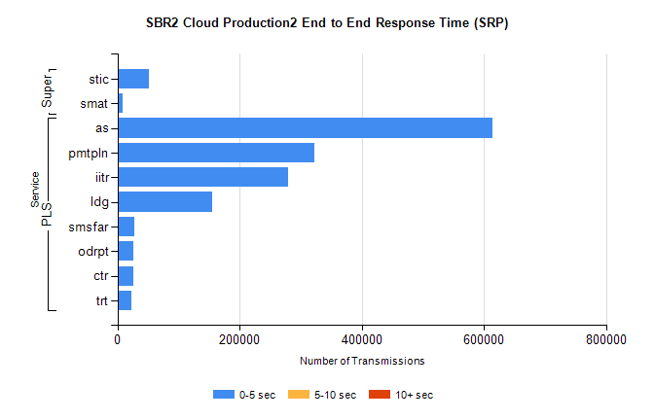
Stream | Service | 0-5 sec | 5-10 sec | >10 sec | Total | % within 5 sec timing target
PLS | as | 614863 | 0 | 0 | 614863 | 100.0%
PLS | pmtpln | 322317 | 0 | 0 | 322317 | 100.0%
PLS | iitr | 279639 | 0 | 0 | 279639 | 100.0%
PLS | ldg | 154619 | 0 | 0 | 154619 | 100.0%
PLS | smsfar | 27411 | 0 | 0 | 27411 | 100.0%
PLS | odrpt | 26076 | 0 | 0 | 26076 | 100.0%
PLS | ctr | 25912 | 0 | 0 | 25912 | 100.0%
PLS | trt | 22269 | 0 | 0 | 22269 | 100.0%
Super | stic | 51361 | 0 | 0 | 51361 | 100.0%
Super | smat | 8610 | 0 | 0 | 8610 | 100.0%

SBR2 Cloud Production2 - Single | Bulk or Batch Requests | (SRP, BBRP & CHiRPP)

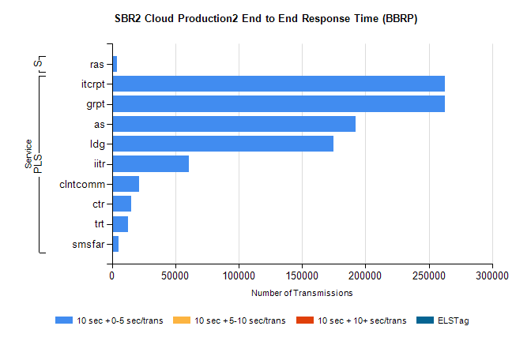
Stream | Service | 10 sec + 0-5 sec /trans | 10 sec + 5-10 sec /trans | 10 sec + >10 sec /trans | Processing Incomplete | ELStag | Total
PLS | grpt | 262641 | 0 | 0 | 0 | 0 | 262641
PLS | itcrpt | 262641 | 0 | 0 | 0 | 0 | 262641
PLS | as | 192066 | 0 | 0 | 0 | 0 | 192066
PLS | ldg | 174825 | 0 | 0 | 0 | 0 | 174825
PLS | iitr | 60899 | 0 | 0 | 0 | 0 | 60899
PLS | clntcomm | 21412 | 0 | 0 | 0 | 0 | 21412
PLS | ctr | 15131 | 0 | 0 | 0 | 0 | 15131
PLS | trt | 12793 | 0 | 0 | 0 | 0 | 12793
PLS | smsfar | 5100 | 0 | 0 | 0 | 0 | 5100
Super | ras | 3722 | 0 | 0 | 0 | 0 | 3722

SBR2 Cloud Production2 - Single | Bulk or Batch Requests | (SRP, BBRP & CHiRPP)

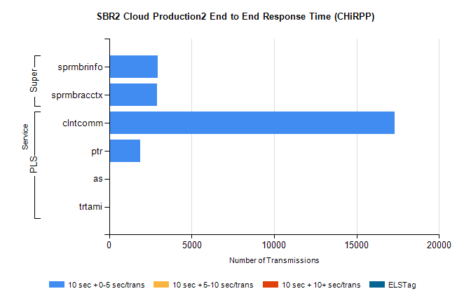
Stream | Service | 10 sec + 0-5 sec /trans | 10 sec + 5-10 sec /trans | 10 sec + >10 sec /trans | Total | % within 5 sec timing target
PLS | clntcomm | 17294 | 0 | 0 | 17294 | 100.0%
PLS | ptr | 1880 | 0 | 0 | 1880 | 100.0%
PLS | as | 57 | 0 | 0 | 57 | 100.0%
PLS | trtami | 21 | 0 | 0 | 21 | 100.0%
Super | sprmbrinfo | 2955 | 0 | 0 | 2955 | 100.0%
Super | sprmbracctx | 2894 | 0 | 0 | 2894 | 100.0%

SBR1 Production Transactions

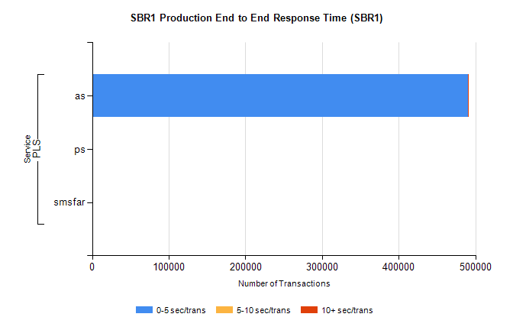
Stream | Service | 0-5 sec/trans | 5-10 sec/trans | 10+ sec/trans | Total | % within 5 sec timing target
PLS | as | 490338 | 224 | 894 | 491456 | 99.8%
PLS | ps | 17 | 31 | 101 | 149 | 11.4%
PLS | smsfar |  | 9 |  | 9 | 0.0%

