Transmission Timings Report Week - 11
9/03/2026 - 15/03/2026

SBR2 External Vendor Testing Environment (EVTE3)

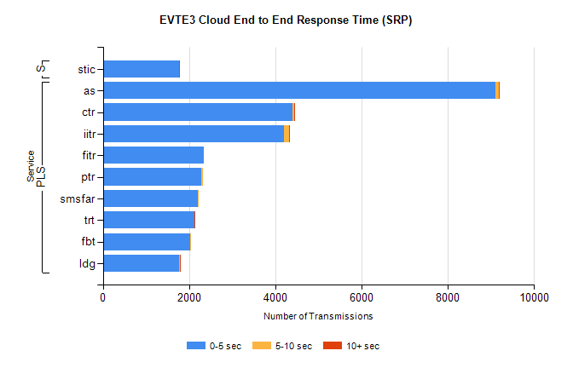
Stream | Service | 0-5 sec | 5-10 sec | >10 sec | Total | % within 5 sec timing target
PLS | as | 9101 | 89 | 14 | 9932 | 91.6%
PLS | ctr | 4393 | 43 | 2 | 4447 | 98.8%
PLS | iitr | 4207 | 119 | 16 | 4366 | 96.4%
PLS | fitr | 2341 | 0 | 0 | 2345 | 99.8%
PLS | ptr | 2292 | 23 | 0 | 2322 | 98.7%
PLS | smsfar | 2198 | 14 | 0 | 2216 | 99.2%
PLS | trt | 2128 | 3 | 4 | 2139 | 99.5%
PLS | fbt | 2027 | 8 | 0 | 2056 | 98.6%
PLS | ldg | 1770 | 16 | 3 | 1803 | 98.2%
Super | stic | 1767 | 3 | 3 | 1773 | 99.7%

SBR2 External Vendor Testing Environment (EVTE3)

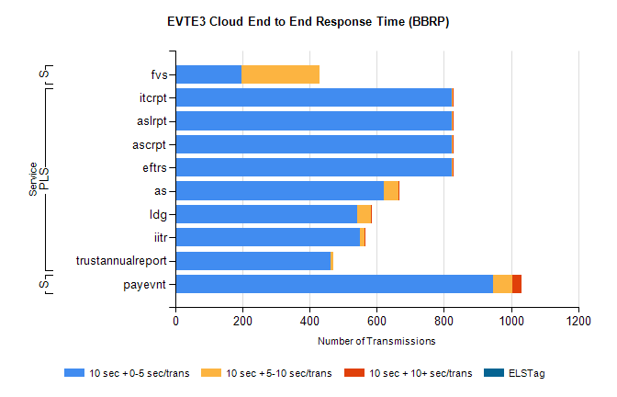
Stream | Service | 10 sec + 0-5 sec /trans | 10 sec + 5-10 sec /trans | 10 sec + >10 sec /trans | Processing Incomplete | ELStag | Total
PLS | eftrs | 822 | 4 | 4 | 8 | 0 | 838
PLS | ascrpt | 822 | 4 | 4 | 8 | 0 | 838
PLS | aslrpt | 822 | 4 | 4 | 8 | 0 | 838
PLS | itcrpt | 822 | 4 | 4 | 8 | 0 | 838
PLS | as | 620 | 44 | 2 | 136 | 0 | 804
PLS | ldg | 541 | 41 | 4 | 30 | 0 | 626
PLS | iitr | 550 | 13 | 4 | 49 | 0 | 623
PLS | trustannualreport | 462 | 8 | 0 | 0 | 0 | 471
STP | payevnt | 947 | 58 | 25 | 63 | 0 | 1107
Super | fvs | 198 | 232 | 0 | 9 | 0 | 445

SBR2 External Vendor Testing Environment (EVTE3)

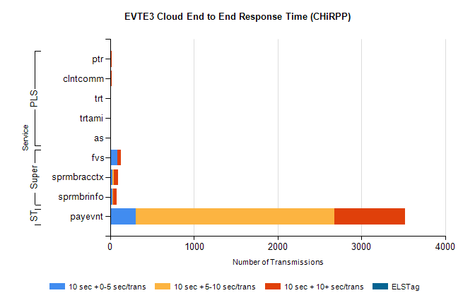
Stream | Service | 10 sec + 0-5 sec /trans | 10 sec + 5-10 sec /trans | 10 sec + >10 sec /trans | Total | % within 5 sec timing target
STP | payevnt | 307 | 2370 | 846 | 4703 | 6.5%
Super | fvs | 83 | 2 | 46 | 192 | 43.2%
Super | sprmbracctx | 27 | 21 | 45 | 113 | 23.9%
Super | sprmbrinfo | 25 | 10 | 44 | 93 | 26.9%
PLS | ptr | 0 | 0 | 20 | 20 | 0.0%
PLS | clntcomm | 0 | 0 | 17 | 17 | 0.0%
PLS | trt | 0 | 0 | 5 | 5 | 0.0%
PLS | as | 0 | 0 | 4 | 4 | 0.0%
PLS | trtami | 0 | 0 | 4 | 4 | 0.0%

