Transmission Timings Report Week - 11
9/03/2026 - 15/03/2026

SBR2 Cloud Production2 - Single | Bulk or Batch Requests | (SRP, BBRP & CHiRPP)

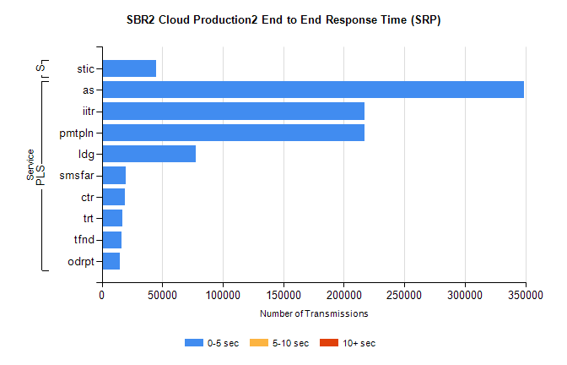
Stream | Service | 0-5 sec | 5-10 sec | >10 sec | Total | % within 5 sec timing target
PLS | as | 348504 | 0 | 0 | 348504 | 100.0%
PLS | iitr | 217315 | 0 | 0 | 217315 | 100.0%
PLS | pmtpln | 216875 | 0 | 0 | 216875 | 100.0%
PLS | ldg | 77421 | 0 | 0 | 77421 | 100.0%
PLS | smsfar | 19575 | 0 | 0 | 19575 | 100.0%
PLS | ctr | 18994 | 0 | 0 | 18994 | 100.0%
PLS | trt | 16902 | 0 | 0 | 16902 | 100.0%
PLS | tfnd | 16087 | 0 | 0 | 16087 | 100.0%
PLS | odrpt | 14955 | 0 | 0 | 14955 | 100.0%
Super | stic | 45127 | 0 | 0 | 45127 | 100.0%

SBR2 Cloud Production2 - Single | Bulk or Batch Requests | (SRP, BBRP & CHiRPP)

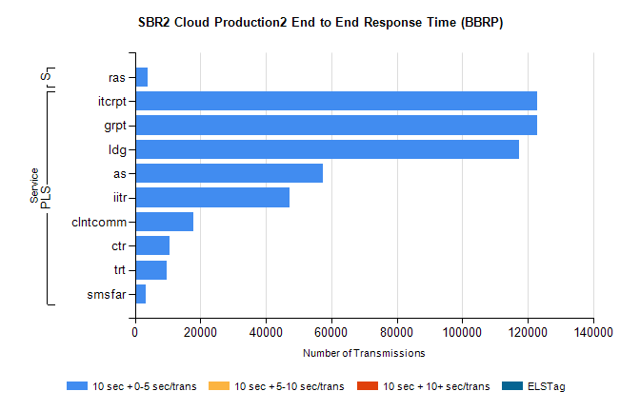
Stream | Service | 10 sec + 0-5 sec /trans | 10 sec + 5-10 sec /trans | 10 sec + >10 sec /trans | Processing Incomplete | ELStag | Total
PLS | grpt | 122916 | 0 | 0 | 0 | 0 | 122916
PLS | itcrpt | 122916 | 0 | 0 | 0 | 0 | 122916
PLS | ldg | 117370 | 0 | 0 | 0 | 0 | 117370
PLS | as | 57506 | 0 | 0 | 0 | 0 | 57506
PLS | iitr | 47258 | 0 | 0 | 0 | 0 | 47258
PLS | clntcomm | 17958 | 0 | 0 | 0 | 0 | 17958
PLS | ctr | 10682 | 0 | 0 | 0 | 0 | 10682
PLS | trt | 9674 | 0 | 0 | 0 | 0 | 9674
PLS | smsfar | 3309 | 0 | 0 | 0 | 0 | 3309
Super | ras | 3732 | 0 | 0 | 0 | 0 | 3732

SBR2 Cloud Production2 - Single | Bulk or Batch Requests | (SRP, BBRP & CHiRPP)

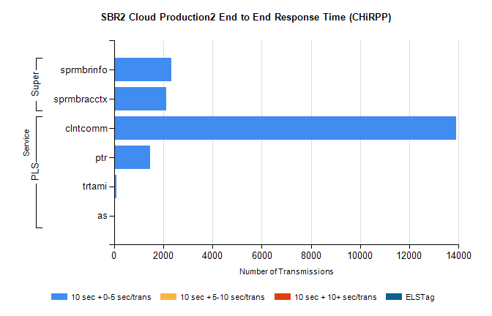
Stream | Service | 10 sec + 0-5 sec /trans | 10 sec + 5-10 sec /trans | 10 sec + >10 sec /trans | Total | % within 5 sec timing target
PLS | clntcomm | 13901 | 0 | 0 | 13901 | 100.0%
PLS | ptr | 1467 | 0 | 0 | 1467 | 100.0%
PLS | trtami | 93 | 0 | 0 | 93 | 100.0%
PLS | as | 42 | 0 | 0 | 42 | 100.0%
Super | sprmbrinfo | 2333 | 0 | 0 | 2333 | 100.0%
Super | sprmbracctx | 2126 | 0 | 0 | 2126 | 100.0%

SBR1 Production Transactions

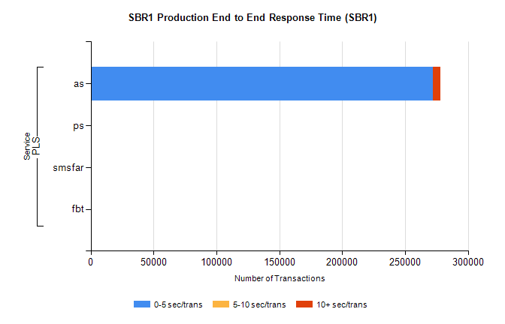
Stream | Service | 0-5 sec/trans | 5-10 sec/trans | 10+ sec/trans | Total | % within 5 sec timing target
PLS | as | 272018 | 222 | 5732 | 277972 | 97.9%
PLS | ps | 28 | 38 | 132 | 198 | 14.1%
PLS | smsfar | 1 | 4 | 1 | 6 | 16.7%
PLS | fbt |  | 1 | 1 | 2 | 0.0%

