Transmission Timings Report Week - 12
16/03/2026 - 22/03/2026

SBR2 External Vendor Testing Environment (EVTE3)

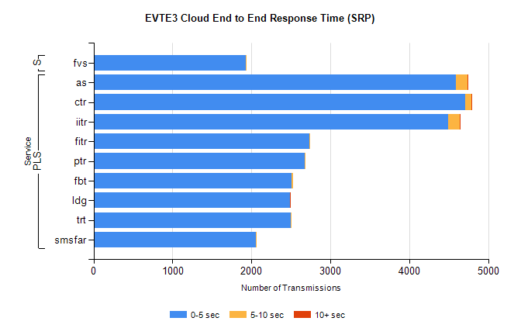
Stream | Service | 0-5 sec | 5-10 sec | >10 sec | Total | % within 5 sec timing target
PLS | as | 4590 | 146 | 13 | 7449 | 61.6%
PLS | ctr | 4712 | 74 | 1 | 4827 | 97.6%
PLS | iitr | 4488 | 147 | 17 | 4660 | 96.3%
PLS | fitr | 2739 | 2 | 0 | 2771 | 98.8%
PLS | ptr | 2680 | 3 | 0 | 2699 | 99.3%
PLS | fbt | 2504 | 23 | 0 | 2527 | 99.1%
PLS | ldg | 2485 | 7 | 4 | 2522 | 98.5%
PLS | trt | 2500 | 3 | 0 | 2507 | 99.7%
PLS | smsfar | 2060 | 2 | 0 | 2063 | 99.9%
Super | fvs | 1926 | 3 | 0 | 1929 | 99.8%

SBR2 External Vendor Testing Environment (EVTE3)

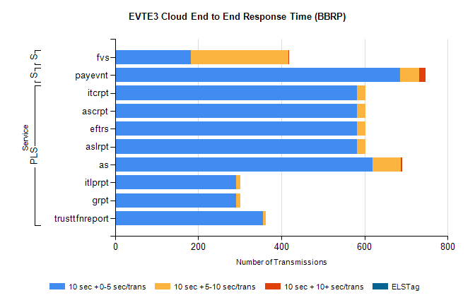
Stream | Service | 10 sec + 0-5 sec /trans | 10 sec + 5-10 sec /trans | 10 sec + >10 sec /trans | Processing Incomplete | ELStag | Total
PLS | aslrpt | 582 | 20 | 0 | 188 | 0 | 790
PLS | eftrs | 582 | 20 | 0 | 188 | 0 | 790
PLS | ascrpt | 582 | 20 | 0 | 188 | 0 | 790
PLS | itcrpt | 582 | 20 | 0 | 188 | 0 | 790
PLS | as | 619 | 69 | 2 | 12 | 0 | 703
PLS | grpt | 291 | 10 | 0 | 94 | 0 | 395
PLS | itlprpt | 291 | 10 | 0 | 94 | 0 | 395
PLS | trusttfnreport | 356 | 6 | 0 | 0 | 0 | 362
STP | payevnt | 686 | 46 | 15 | 207 | 0 | 966
Super | fvs | 183 | 234 | 1 | 14 | 0 | 443

SBR2 External Vendor Testing Environment (EVTE3)

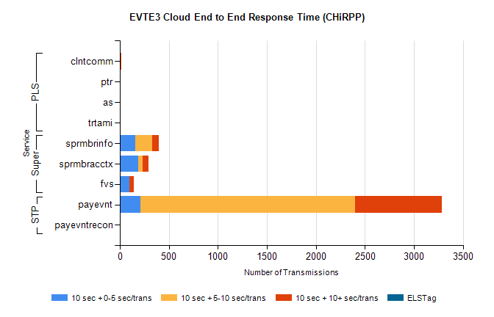
Stream | Service | 10 sec + 0-5 sec /trans | 10 sec + 5-10 sec /trans | 10 sec + >10 sec /trans | Total | % within 5 sec timing target
STP | payevnt | 210 | 2187 | 887 | 4536 | 4.6%
STP | payevntrecon | 0 | 0 | 9 | 11 | 0.0%
Super | sprmbrinfo | 161 | 171 | 69 | 442 | 36.4%
Super | sprmbracctx | 188 | 43 | 61 | 323 | 58.2%
Super | fvs | 96 | 3 | 44 | 212 | 45.3%
PLS | clntcomm | 0 | 0 | 19 | 19 | 0.0%
PLS | ptr | 1 | 1 | 10 | 12 | 8.3%
PLS | trtami | 0 | 0 | 2 | 2 | 0.0%
PLS | as | 0 | 0 | 2 | 2 | 0.0%

