Transmission Timings Report Week - 12
16/03/2026 - 22/03/2026

SBR2 Cloud Production2 - Single | Bulk or Batch Requests | (SRP, BBRP & CHiRPP)

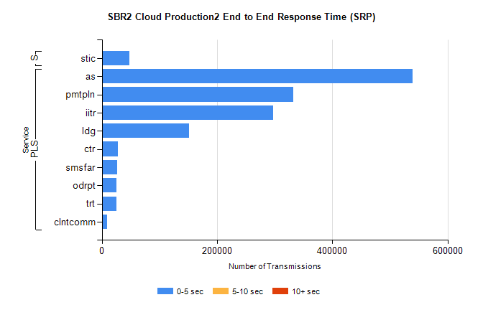
Stream | Service | 0-5 sec | 5-10 sec | >10 sec | Total | % within 5 sec timing target
PLS | as | 539644 | 0 | 0 | 539644 | 100.0%
PLS | pmtpln | 332275 | 0 | 0 | 332275 | 100.0%
PLS | iitr | 297232 | 0 | 0 | 297232 | 100.0%
PLS | ldg | 151411 | 0 | 0 | 151411 | 100.0%
PLS | ctr | 28188 | 0 | 0 | 28188 | 100.0%
PLS | smsfar | 26754 | 0 | 0 | 26754 | 100.0%
PLS | odrpt | 25496 | 0 | 0 | 25496 | 100.0%
PLS | trt | 25479 | 0 | 0 | 25479 | 100.0%
PLS | clntcomm | 8664 | 0 | 0 | 8664 | 100.0%
Super | stic | 47901 | 0 | 0 | 47901 | 100.0%

SBR2 Cloud Production2 - Single | Bulk or Batch Requests | (SRP, BBRP & CHiRPP)

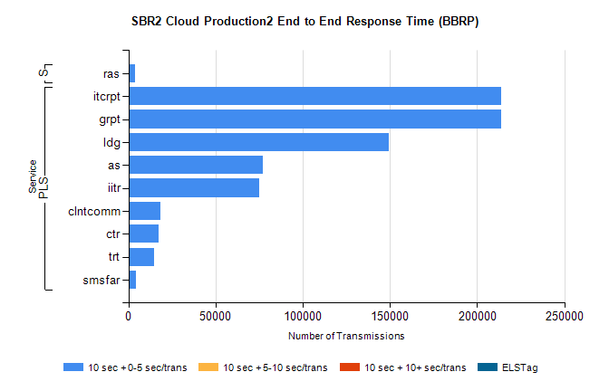
Stream | Service | 10 sec + 0-5 sec /trans | 10 sec + 5-10 sec /trans | 10 sec + >10 sec /trans | Processing Incomplete | ELStag | Total
PLS | grpt | 213914 | 0 | 0 | 0 | 0 | 213914
PLS | itcrpt | 213914 | 0 | 0 | 0 | 0 | 213914
PLS | ldg | 149085 | 0 | 0 | 0 | 0 | 149085
PLS | as | 77118 | 0 | 0 | 0 | 0 | 77118
PLS | iitr | 74745 | 0 | 0 | 0 | 0 | 74745
PLS | clntcomm | 18274 | 0 | 0 | 0 | 0 | 18274
PLS | ctr | 17065 | 0 | 0 | 0 | 0 | 17065
PLS | trt | 14634 | 0 | 0 | 0 | 0 | 14634
PLS | smsfar | 4569 | 0 | 0 | 0 | 0 | 4569
Super | ras | 3653 | 0 | 0 | 0 | 0 | 3653

SBR2 Cloud Production2 - Single | Bulk or Batch Requests | (SRP, BBRP & CHiRPP)

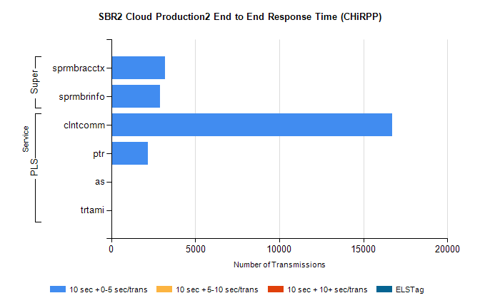
Stream | Service | 10 sec + 0-5 sec /trans | 10 sec + 5-10 sec /trans | 10 sec + >10 sec /trans | Total | % within 5 sec timing target
PLS | clntcomm | 16709 | 0 | 0 | 16709 | 100.0%
PLS | ptr | 2156 | 0 | 0 | 2156 | 100.0%
PLS | as | 52 | 0 | 0 | 52 | 100.0%
PLS | trtami | 23 | 0 | 0 | 23 | 100.0%
Super | sprmbracctx | 3190 | 0 | 0 | 3190 | 100.0%
Super | sprmbrinfo | 2897 | 0 | 0 | 2897 | 100.0%

SBR1 Production Transactions

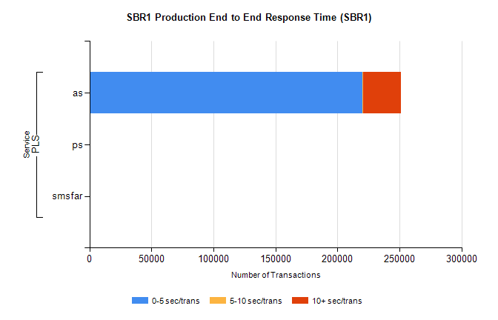
Stream | Service | 0-5 sec/trans | 5-10 sec/trans | 10+ sec/trans | Total | % within 5 sec timing target
PLS | as | 220275 | 666 | 30077 | 251018 | 87.8%
PLS | ps | 68 | 36 | 128 | 232 | 29.3%
PLS | smsfar |  | 3 | 1 | 4 | 0.0%

