Transmission Timings Report Week - 13
23/03/2026 - 29/03/2026

SBR2 External Vendor Testing Environment (EVTE3)

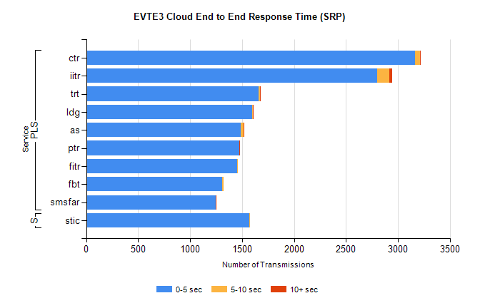
Stream | Service | 0-5 sec | 5-10 sec | >10 sec | Total | % within 5 sec timing target
PLS | ctr | 3168 | 47 | 2 | 3259 | 97.2%
PLS | iitr | 2798 | 122 | 23 | 3048 | 91.8%
PLS | trt | 1659 | 12 | 3 | 1694 | 97.9%
PLS | ldg | 1598 | 10 | 2 | 1631 | 98.0%
PLS | as | 1485 | 30 | 3 | 1572 | 94.5%
PLS | ptr | 1474 | 3 | 1 | 1502 | 98.1%
PLS | fitr | 1455 | 1 | 0 | 1468 | 99.1%
PLS | fbt | 1310 | 13 | 0 | 1332 | 98.3%
PLS | smsfar | 1247 | 2 | 2 | 1260 | 99.0%
Super | stic | 1571 | 7 | 0 | 1578 | 99.6%

SBR2 External Vendor Testing Environment (EVTE3)

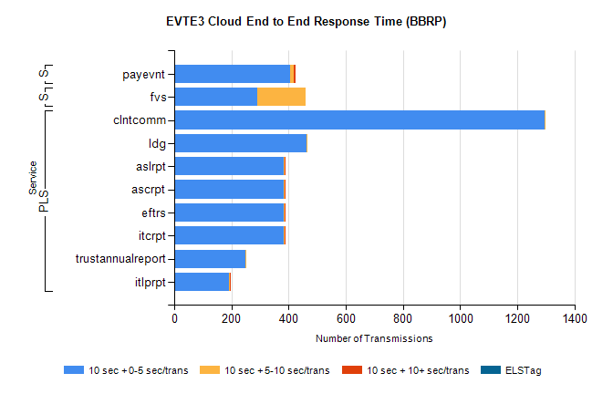
Stream | Service | 10 sec + 0-5 sec /trans | 10 sec + 5-10 sec /trans | 10 sec + >10 sec /trans | Processing Incomplete | ELStag | Total
PLS | clntcomm | 1295 | 4 | 0 | 29 | 0 | 1328
PLS | ldg | 464 | 3 | 0 | 10 | 0 | 477
PLS | itcrpt | 382 | 4 | 2 | 6 | 0 | 394
PLS | eftrs | 382 | 4 | 2 | 6 | 0 | 394
PLS | ascrpt | 382 | 4 | 2 | 6 | 0 | 394
PLS | aslrpt | 382 | 4 | 2 | 6 | 0 | 394
PLS | trustannualreport | 249 | 2 | 0 | 0 | 0 | 251
PLS | itlprpt | 191 | 2 | 1 | 3 | 0 | 197
STP | payevnt | 404 | 13 | 7 | 58 | 0 | 497
Super | fvs | 289 | 170 | 0 | 19 | 0 | 479

SBR2 External Vendor Testing Environment (EVTE3)

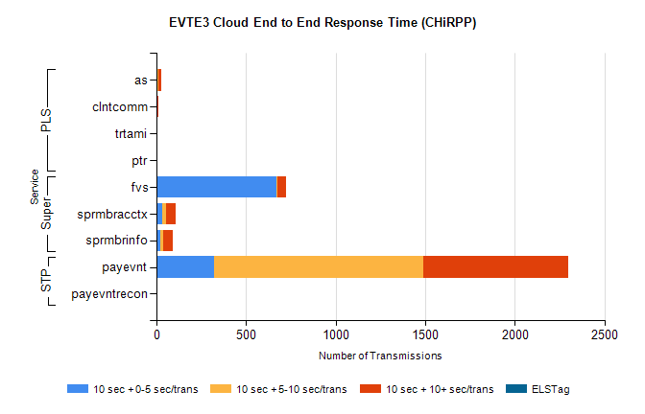
Stream | Service | 10 sec + 0-5 sec /trans | 10 sec + 5-10 sec /trans | 10 sec + >10 sec /trans | Total | % within 5 sec timing target
STP | payevnt | 322 | 1167 | 808 | 3485 | 9.2%
STP | payevntrecon | 0 | 0 | 3 | 5 | 0.0%
Super | fvs | 668 | 7 | 51 | 794 | 84.1%
Super | sprmbracctx | 33 | 19 | 58 | 142 | 23.2%
Super | sprmbrinfo | 24 | 16 | 51 | 105 | 22.9%
PLS | as | 6 | 6 | 16 | 38 | 15.8%
PLS | clntcomm | 0 | 0 | 12 | 28 | 0.0%
PLS | trtami | 1 | 0 | 6 | 7 | 14.3%
PLS | ptr | 0 | 0 | 1 | 2 | 0.0%

