Transmission Timings Report Week - 13
23/03/2026 - 29/03/2026

SBR2 Cloud Production2 - Single | Bulk or Batch Requests | (SRP, BBRP & CHiRPP)

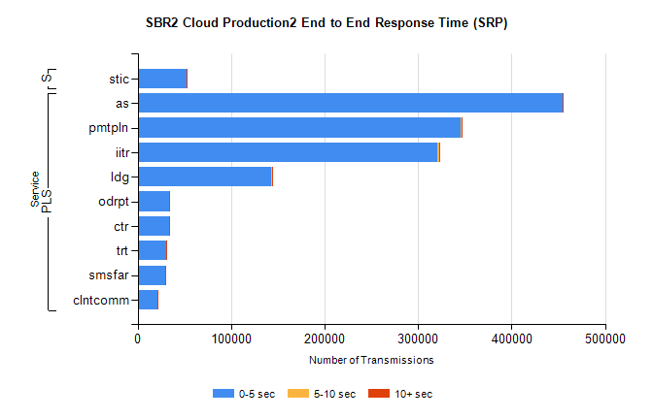
Stream | Service | 0-5 sec | 5-10 sec | >10 sec | Total | % within 5 sec timing target
PLS | as | 454435 | 327 | 38 | 454800 | 99.9%
PLS | pmtpln | 345841 | 390 | 5 | 346236 | 99.9%
PLS | iitr | 320849 | 1330 | 198 | 322377 | 99.5%
PLS | ldg | 143193 | 205 | 13 | 143411 | 99.8%
PLS | odrpt | 33824 | 214 | 61 | 34099 | 99.2%
PLS | ctr | 33466 | 53 | 1 | 33520 | 99.8%
PLS | trt | 30754 | 61 | 3 | 30818 | 99.8%
PLS | smsfar | 29675 | 45 | 12 | 29732 | 99.8%
PLS | clntcomm | 21518 | 31 | 3 | 21552 | 99.8%
Super | stic | 51834 | 69 | 43 | 51946 | 99.8%

SBR2 Cloud Production2 - Single | Bulk or Batch Requests | (SRP, BBRP & CHiRPP)

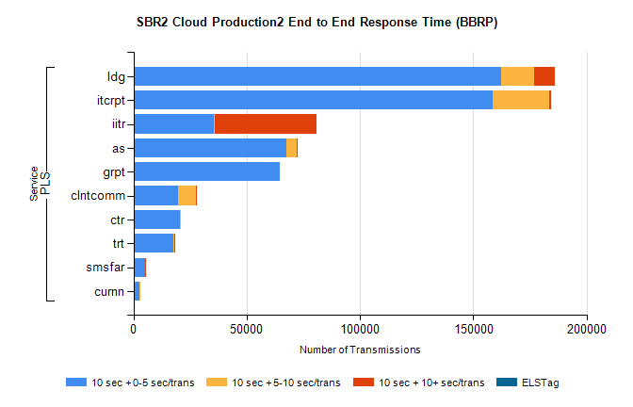
Stream | Service | 10 sec + 0-5 sec /trans | 10 sec + 5-10 sec /trans | 10 sec + >10 sec /trans | Processing Incomplete | ELStag | Total
PLS | ldg | 162255 | 14783 | 9024 | 0 | 0 | 189697
PLS | itcrpt | 158540 | 24975 | 833 | 0 | 0 | 185736
PLS | iitr | 35360 | 667 | 44610 | 0 | 0 | 82293
PLS | as | 67300 | 4736 | 9 | 0 | 0 | 72068
PLS | grpt | 64385 | 0 | 0 | 0 | 0 | 64385
PLS | clntcomm | 19656 | 7746 | 451 | 0 | 0 | 28369
PLS | ctr | 20467 | 241 | 0 | 0 | 0 | 20721
PLS | trt | 17638 | 192 | 1 | 0 | 0 | 17843
PLS | smsfar | 5021 | 55 | 1 | 0 | 0 | 5080
PLS | curnn | 2482 | 236 | 0 | 0 | 0 | 2719

SBR2 Cloud Production2 - Single | Bulk or Batch Requests | (SRP, BBRP & CHiRPP)

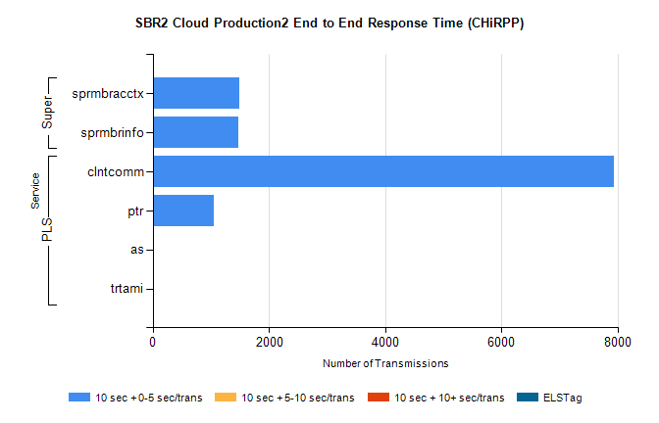
Stream | Service | 10 sec + 0-5 sec /trans | 10 sec + 5-10 sec /trans | 10 sec + >10 sec /trans | Total | % within 5 sec timing target
PLS | clntcomm | 7933 | 0 | 0 | 7933 | 100.0%
PLS | ptr | 1047 | 0 | 0 | 1047 | 100.0%
PLS | as | 25 | 0 | 0 | 25 | 100.0%
PLS | trtami | 7 | 0 | 0 | 7 | 100.0%
Super | sprmbracctx | 1497 | 0 | 0 | 1497 | 100.0%
Super | sprmbrinfo | 1464 | 0 | 0 | 1464 | 100.0%

SBR1 Production Transactions

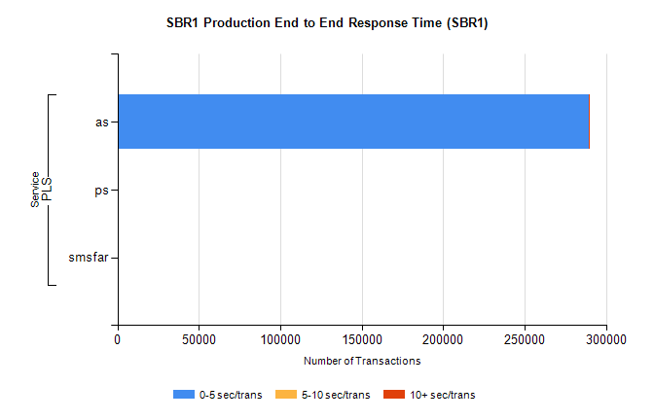
Stream | Service | 0-5 sec/trans | 5-10 sec/trans | 10+ sec/trans | Total | % within 5 sec timing target
PLS | as | 289469 | 181 | 306 | 289956 | 99.8%
PLS | ps | 185 | 50 | 147 | 382 | 48.4%
PLS | smsfar |  | 5 |  | 5 | 0.0%

