Transmission Timings Report Week - 9
23/02/2026 - 1/03/2026

SBR2 External Vendor Testing Environment (EVTE3)

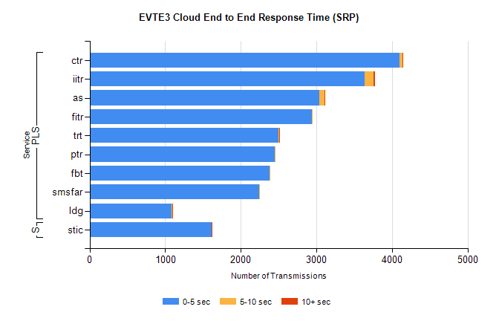
Stream | Service | 0-5 sec | 5-10 sec | >10 sec | Total | % within 5 sec timing target
PLS | ctr | 4098 | 44 | 1 | 4155 | 98.6%
PLS | iitr | 3638 | 117 | 20 | 3776 | 96.3%
PLS | as | 3041 | 64 | 3 | 3137 | 96.9%
PLS | fitr | 2941 | 3 | 0 | 2944 | 99.9%
PLS | trt | 2502 | 4 | 1 | 2509 | 99.7%
PLS | ptr | 2450 | 4 | 0 | 2460 | 99.6%
PLS | fbt | 2385 | 10 | 0 | 2409 | 99.0%
PLS | smsfar | 2242 | 4 | 0 | 2246 | 99.8%
PLS | ldg | 1087 | 12 | 1 | 1113 | 97.7%
Super | stic | 1610 | 9 | 2 | 1621 | 99.3%

SBR2 External Vendor Testing Environment (EVTE3)

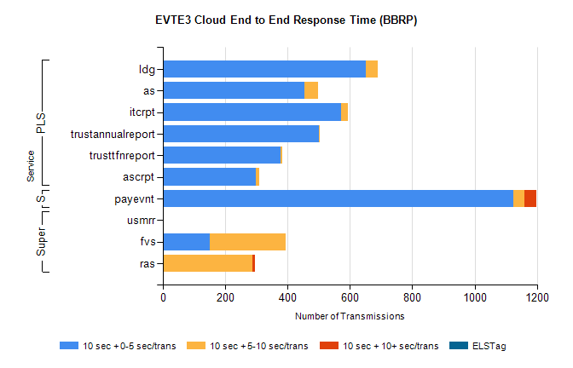
Stream | Service | 10 sec + 0-5 sec /trans | 10 sec + 5-10 sec /trans | 10 sec + >10 sec /trans | Processing Incomplete | ELStag | Total
PLS | ldg | 650 | 40 | 0 | 4 | 0 | 703
PLS | as | 454 | 45 | 0 | 168 | 0 | 667
PLS | itcrpt | 572 | 22 | 0 | 0 | 0 | 594
PLS | trustannualreport | 501 | 1 | 0 | 0 | 0 | 502
PLS | trusttfnreport | 378 | 4 | 0 | 0 | 0 | 382
PLS | ascrpt | 298 | 12 | 0 | 0 | 0 | 310
Super | usmrr | 0 | 0 | 0 | 1644 | 0 | 1644
Super | fvs | 151 | 244 | 0 | 17 | 0 | 418
Super | ras | 1 | 287 | 6 | 0 | 0 | 316
STP | payevnt | 1125 | 34 | 39 | 45 | 0 | 1256

SBR2 External Vendor Testing Environment (EVTE3)

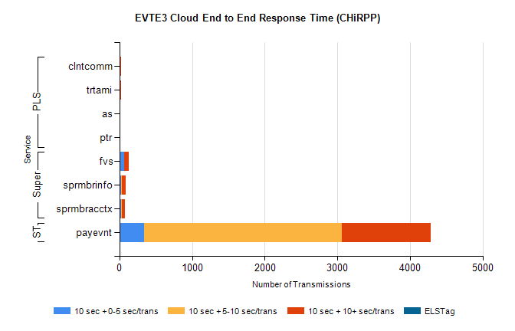
Stream | Service | 10 sec + 0-5 sec /trans | 10 sec + 5-10 sec /trans | 10 sec + >10 sec /trans | Total | % within 5 sec timing target
STP | payevnt | 335 | 2730 | 1221 | 6022 | 5.6%
Super | fvs | 67 | 0 | 57 | 148 | 45.3%
Super | sprmbrinfo | 19 | 10 | 62 | 104 | 18.3%
Super | sprmbracctx | 20 | 15 | 38 | 88 | 22.7%
PLS | clntcomm | 0 | 2 | 23 | 25 | 0.0%
PLS | trtami | 8 | 1 | 8 | 23 | 34.8%
PLS | as | 0 | 0 | 6 | 6 | 0.0%
PLS | ptr | 0 | 0 | 2 | 2 | 0.0%

