Transmission Timings Report Week - 9
23/02/2026 - 1/03/2026

SBR2 Cloud Production2 - Single | Bulk or Batch Requests | (SRP, BBRP & CHiRPP)

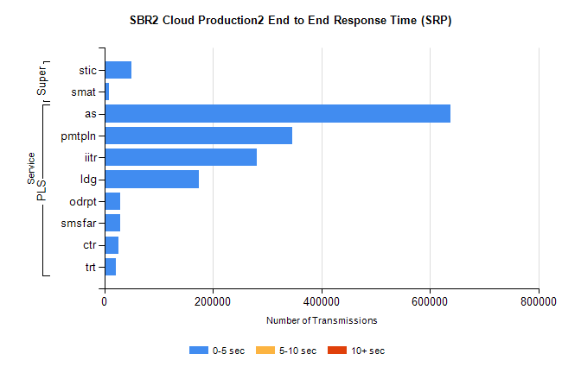
Stream | Service | 0-5 sec | 5-10 sec | >10 sec | Total | % within 5 sec timing target
PLS | as | 638451 | 0 | 0 | 638451 | 100.0%
PLS | pmtpln | 346680 | 0 | 0 | 346680 | 100.0%
PLS | iitr | 280873 | 0 | 0 | 280873 | 100.0%
PLS | ldg | 174285 | 0 | 0 | 174285 | 100.0%
PLS | odrpt | 29664 | 0 | 0 | 29664 | 100.0%
PLS | smsfar | 28696 | 0 | 0 | 28696 | 100.0%
PLS | ctr | 25605 | 0 | 0 | 25605 | 100.0%
PLS | trt | 21269 | 0 | 0 | 21269 | 100.0%
Super | stic | 50453 | 0 | 0 | 50453 | 100.0%
Super | smat | 8220 | 0 | 0 | 8220 | 100.0%

SBR2 Cloud Production2 - Single | Bulk or Batch Requests | (SRP, BBRP & CHiRPP)

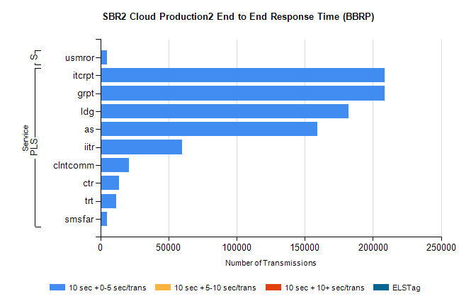
Stream | Service | 10 sec + 0-5 sec /trans | 10 sec + 5-10 sec /trans | 10 sec + >10 sec /trans | Processing Incomplete | ELStag | Total
PLS | grpt | 208824 | 0 | 0 | 0 | 0 | 208824
PLS | itcrpt | 208824 | 0 | 0 | 0 | 0 | 208824
PLS | ldg | 182089 | 0 | 0 | 0 | 0 | 182089
PLS | as | 159048 | 0 | 0 | 0 | 0 | 159048
PLS | iitr | 59690 | 0 | 0 | 0 | 0 | 59690
PLS | clntcomm | 20924 | 0 | 0 | 0 | 0 | 20924
PLS | ctr | 13894 | 0 | 0 | 0 | 0 | 13894
PLS | trt | 11774 | 0 | 0 | 0 | 0 | 11774
PLS | smsfar | 5001 | 0 | 0 | 0 | 0 | 5001
Super | usmror | 4664 | 0 | 0 | 0 | 0 | 4664

SBR2 Cloud Production2 - Single | Bulk or Batch Requests | (SRP, BBRP & CHiRPP)

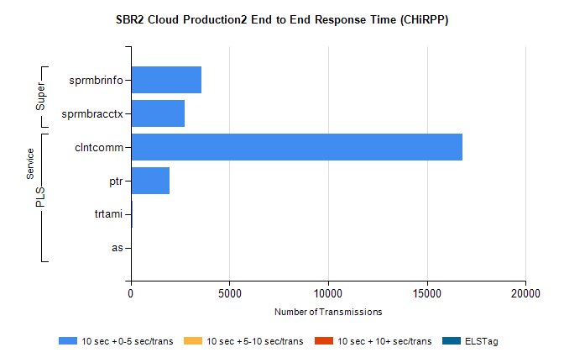
Stream | Service | 10 sec + 0-5 sec /trans | 10 sec + 5-10 sec /trans | 10 sec + >10 sec /trans | Total | % within 5 sec timing target
PLS | clntcomm | 16791 | 0 | 0 | 16791 | 100.0%
PLS | ptr | 1945 | 0 | 0 | 1945 | 100.0%
PLS | trtami | 76 | 0 | 0 | 76 | 100.0%
PLS | as | 56 | 0 | 0 | 56 | 100.0%
Super | sprmbrinfo | 3594 | 0 | 0 | 3594 | 100.0%
Super | sprmbracctx | 2732 | 0 | 0 | 2732 | 100.0%

SBR1 Production Transactions

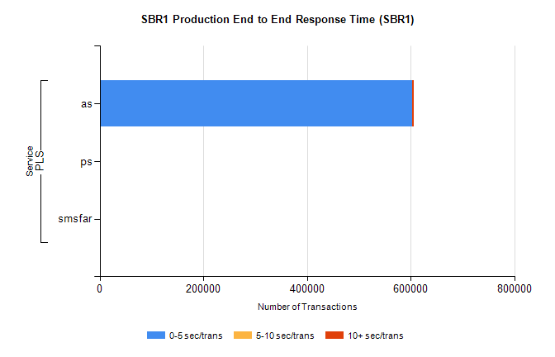
Stream | Service | 0-5 sec/trans | 5-10 sec/trans | 10+ sec/trans | Total | % within 5 sec timing target
PLS | as | 602634 | 236 | 2462 | 605332 | 99.6%
PLS | ps | 18 | 22 | 87 | 127 | 14.2%
PLS | smsfar | 1 | 5 |  | 6 | 16.7%

