Transmission Timings Report Week - 14
30/03/2026 - 5/04/2026

SBR2 External Vendor Testing Environment (EVTE3)

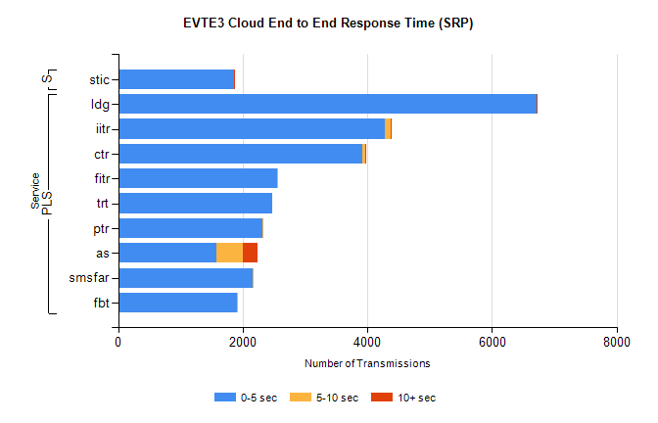
Stream | Service | 0-5 sec | 5-10 sec | >10 sec | Total | % within 5 sec timing target
PLS | ldg | 6711 | 9 | 3 | 6731 | 99.7%
PLS | iitr | 4279 | 91 | 14 | 4407 | 97.1%
PLS | ctr | 3921 | 47 | 1 | 3994 | 98.2%
PLS | fitr | 2547 | 6 | 0 | 2585 | 98.5%
PLS | trt | 2472 | 0 | 0 | 2484 | 99.5%
PLS | ptr | 2324 | 7 | 0 | 2352 | 98.8%
PLS | as | 1584 | 419 | 235 | 2275 | 69.6%
PLS | smsfar | 2160 | 15 | 0 | 2175 | 99.3%
PLS | fbt | 1907 | 19 | 0 | 1938 | 98.4%
Super | stic | 1859 | 7 | 1 | 1868 | 99.5%

SBR2 External Vendor Testing Environment (EVTE3)

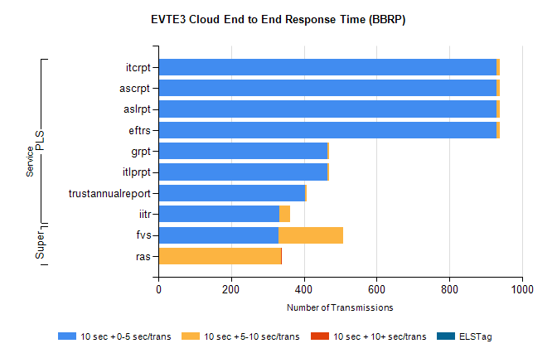
Stream | Service | 10 sec + 0-5 sec /trans | 10 sec + 5-10 sec /trans | 10 sec + >10 sec /trans | Processing Incomplete | ELStag | Total
PLS | eftrs | 930 | 8 | 0 | 56 | 0 | 996
PLS | aslrpt | 930 | 8 | 0 | 56 | 0 | 996
PLS | ascrpt | 930 | 8 | 0 | 56 | 0 | 996
PLS | itcrpt | 930 | 8 | 0 | 56 | 0 | 996
PLS | itlprpt | 465 | 4 | 0 | 28 | 0 | 498
PLS | grpt | 465 | 4 | 0 | 28 | 0 | 498
PLS | trustannualreport | 403 | 5 | 0 | 0 | 0 | 408
PLS | iitr | 333 | 30 | 0 | 12 | 0 | 381
Super | fvs | 331 | 177 | 0 | 5 | 0 | 515
Super | ras | 0 | 338 | 2 | 0 | 0 | 355

SBR2 External Vendor Testing Environment (EVTE3)

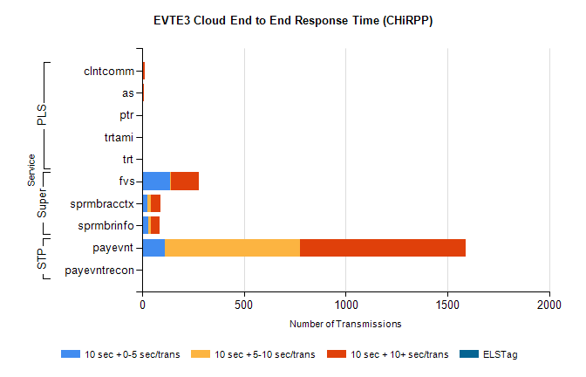
Stream | Service | 10 sec + 0-5 sec /trans | 10 sec + 5-10 sec /trans | 10 sec + >10 sec /trans | Total | % within 5 sec timing target
STP | payevnt | 111 | 665 | 813 | 2377 | 4.7%
STP | payevntrecon | 0 | 0 | 3 | 3 | 0.0%
Super | fvs | 137 | 4 | 137 | 399 | 34.3%
Super | sprmbracctx | 27 | 15 | 47 | 111 | 24.3%
Super | sprmbrinfo | 29 | 14 | 44 | 104 | 27.9%
PLS | clntcomm | 0 | 0 | 15 | 15 | 0.0%
PLS | as | 0 | 3 | 7 | 12 | 0.0%
PLS | ptr | 0 | 1 | 5 | 7 | 0.0%
PLS | trtami | 0 | 0 | 4 | 4 | 0.0%
PLS | trt | 0 | 0 | 1 | 1 | 0.0%

