Transmission Timings Report Week - 14
30/03/2026 - 5/04/2026

SBR2 Cloud Production2 - Single | Bulk or Batch Requests | (SRP, BBRP & CHiRPP)

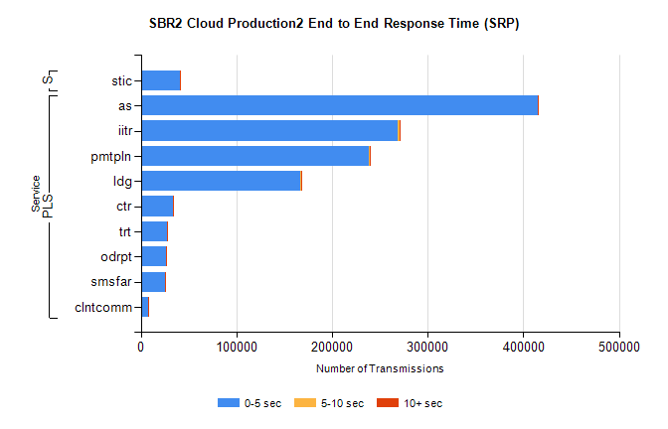
Stream | Service | 0-5 sec | 5-10 sec | >10 sec | Total | % within 5 sec timing target
PLS | as | 415039 | 339 | 114 | 415492 | 99.9%
PLS | iitr | 268680 | 1527 | 252 | 270459 | 99.3%
PLS | pmtpln | 238710 | 400 | 451 | 239561 | 99.6%
PLS | ldg | 167001 | 275 | 122 | 167398 | 99.8%
PLS | ctr | 33145 | 58 | 5 | 33208 | 99.8%
PLS | trt | 27774 | 65 | 7 | 27846 | 99.7%
PLS | odrpt | 26250 | 84 | 126 | 26460 | 99.2%
PLS | smsfar | 25636 | 50 | 13 | 25699 | 99.8%
PLS | clntcomm | 7164 | 186 | 72 | 7422 | 96.5%
Super | stic | 40662 | 90 | 43 | 40795 | 99.7%

SBR2 Cloud Production2 - Single | Bulk or Batch Requests | (SRP, BBRP & CHiRPP)

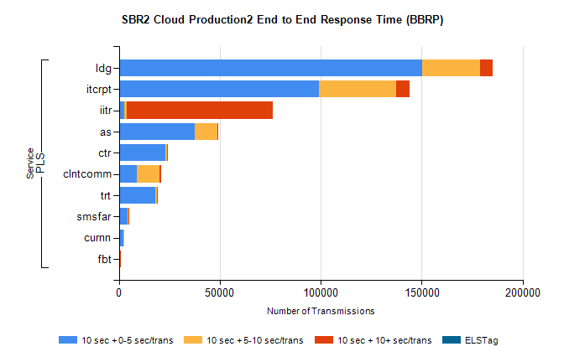
Stream | Service | 10 sec + 0-5 sec /trans | 10 sec + 5-10 sec /trans | 10 sec + >10 sec /trans | Processing Incomplete | ELStag | Total
PLS | ldg | 150271 | 28678 | 6195 | 0 | 0 | 190831
PLS | itcrpt | 98995 | 38411 | 6520 | 0 | 0 | 147065
PLS | iitr | 2703 | 1206 | 72255 | 0 | 0 | 81064
PLS | as | 37638 | 11194 | 412 | 0 | 0 | 49542
PLS | ctr | 22990 | 942 | 20 | 0 | 0 | 23991
PLS | clntcomm | 8657 | 11506 | 851 | 0 | 0 | 22133
PLS | trt | 18105 | 672 | 21 | 0 | 0 | 18827
PLS | smsfar | 4320 | 220 | 3 | 0 | 0 | 4552
PLS | curnn | 2019 | 558 | 0 | 0 | 0 | 2588
PLS | fbt | 539 | 40 | 1 | 0 | 0 | 583

SBR2 Cloud Production2 - Single | Bulk or Batch Requests | (SRP, BBRP & CHiRPP)

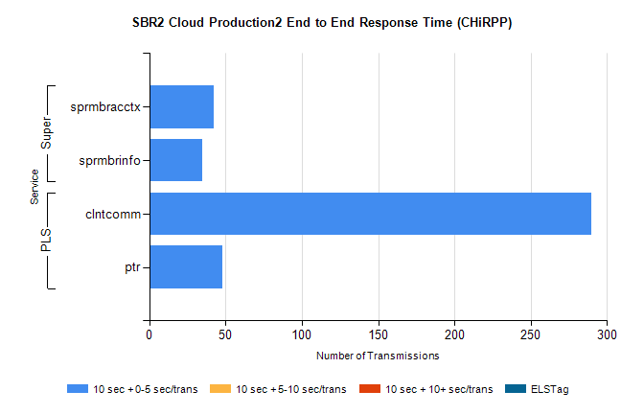
Stream | Service | 10 sec + 0-5 sec /trans | 10 sec + 5-10 sec /trans | 10 sec + >10 sec /trans | Total | % within 5 sec timing target
PLS | clntcomm | 290 | 0 | 0 | 290 | 100.0%
PLS | ptr | 48 | 0 | 0 | 48 | 100.0%
Super | sprmbracctx | 42 | 0 | 0 | 42 | 100.0%
Super | sprmbrinfo | 35 | 0 | 0 | 35 | 100.0%

SBR1 Production Transactions

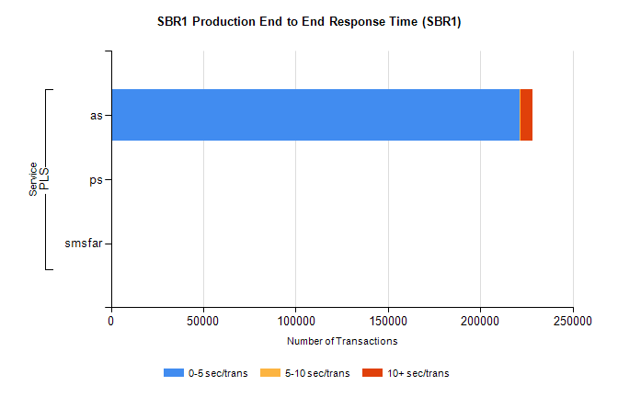
Stream | Service | 0-5 sec/trans | 5-10 sec/trans | 10+ sec/trans | Total | % within 5 sec timing target
PLS | as | 221290 | 241 | 6871 | 228402 | 96.9%
PLS | ps | 11 | 16 | 82 | 109 | 10.1%
PLS | smsfar | 1 | 7 |  | 8 | 12.5%

