Transmission Timings Report Week - 15
6/04/2026 - 12/04/2026

SBR2 External Vendor Testing Environment (EVTE3)

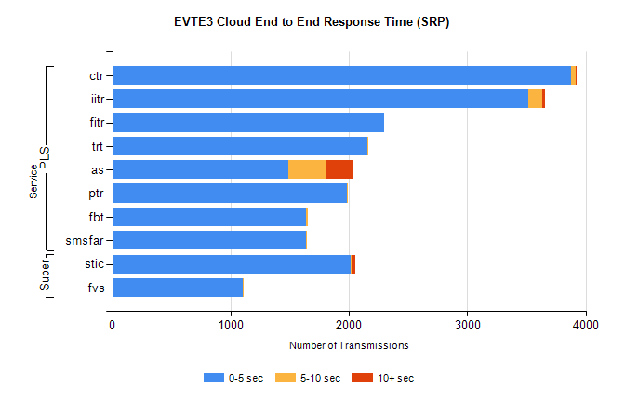
Stream | Service | 0-5 sec | 5-10 sec | >10 sec | Total | % within 5 sec timing target
PLS | ctr | 3880 | 37 | 2 | 3927 | 98.8%
PLS | iitr | 3514 | 122 | 17 | 3670 | 95.7%
PLS | fitr | 2300 | 0 | 0 | 2303 | 99.9%
PLS | trt | 2154 | 7 | 0 | 2167 | 99.4%
PLS | as | 1485 | 324 | 226 | 2050 | 72.4%
PLS | ptr | 1981 | 3 | 0 | 1986 | 99.7%
PLS | fbt | 1636 | 19 | 0 | 1655 | 98.9%
PLS | smsfar | 1637 | 5 | 0 | 1642 | 99.7%
Super | stic | 2017 | 5 | 31 | 2091 | 96.5%
Super | fvs | 1106 | 3 | 0 | 1109 | 99.7%

SBR2 External Vendor Testing Environment (EVTE3)

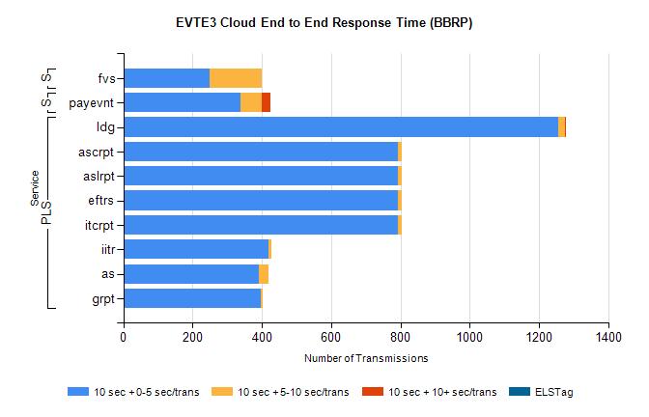
Stream | Service | 10 sec + 0-5 sec /trans | 10 sec + 5-10 sec /trans | 10 sec + >10 sec /trans | Processing Incomplete | ELStag | Total
PLS | ldg | 1255 | 19 | 5 | 171 | 0 | 1460
PLS | itcrpt | 792 | 12 | 0 | 54 | 0 | 858
PLS | eftrs | 792 | 12 | 0 | 54 | 0 | 858
PLS | aslrpt | 792 | 12 | 0 | 54 | 0 | 858
PLS | ascrpt | 792 | 12 | 0 | 54 | 0 | 858
PLS | iitr | 418 | 9 | 0 | 5 | 0 | 436
PLS | as | 391 | 29 | 0 | 5 | 0 | 431
PLS | grpt | 396 | 6 | 0 | 27 | 0 | 429
STP | payevnt | 339 | 61 | 25 | 44 | 0 | 538
Super | fvs | 249 | 151 | 0 | 29 | 0 | 431

SBR2 External Vendor Testing Environment (EVTE3)

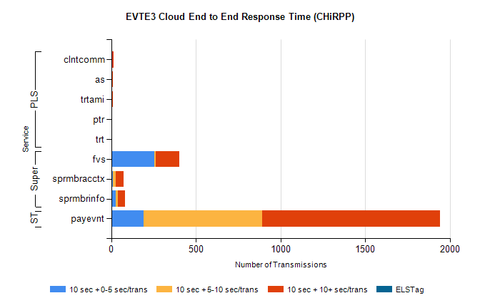
Stream | Service | 10 sec + 0-5 sec /trans | 10 sec + 5-10 sec /trans | 10 sec + >10 sec /trans | Total | % within 5 sec timing target
STP | payevnt | 189 | 702 | 1050 | 2852 | 6.8%
Super | fvs | 255 | 9 | 138 | 531 | 48.3%
Super | sprmbracctx | 10 | 15 | 47 | 100 | 10.1%
Super | sprmbrinfo | 25 | 15 | 42 | 94 | 26.6%
PLS | clntcomm | 0 | 0 | 12 | 12 | 0.0%
PLS | as | 0 | 0 | 8 | 11 | 0.0%
PLS | trtami | 0 | 0 | 8 | 8 | 0.0%
PLS | trt | 0 | 0 | 5 | 5 | 0.0%
PLS | ptr | 0 | 0 | 5 | 5 | 0.0%

