Transmission Timings Report Week - 15
6/04/2026 - 12/04/2026

SBR2 Cloud Production2 - Single | Bulk or Batch Requests | (SRP, BBRP & CHiRPP)

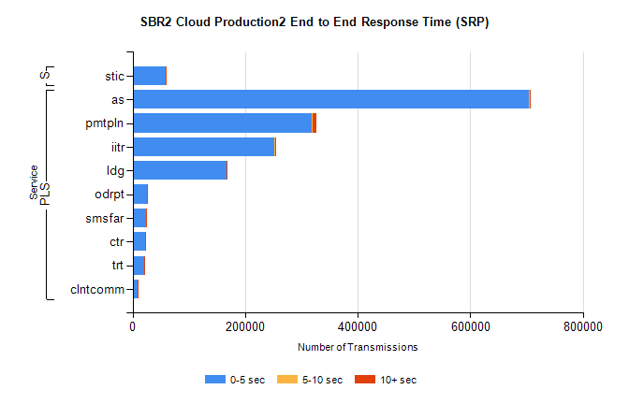
Stream | Service | 0-5 sec | 5-10 sec | >10 sec | Total | % within 5 sec timing target
PLS | as | 703440 | 1539 | 414 | 705393 | 99.7%
PLS | pmtpln | 318846 | 704 | 6525 | 326075 | 97.8%
PLS | iitr | 251452 | 1751 | 341 | 253544 | 99.2%
PLS | ldg | 166429 | 334 | 299 | 167062 | 99.6%
PLS | odrpt | 25713 | 232 | 166 | 26111 | 98.5%
PLS | smsfar | 23514 | 54 | 17 | 23585 | 99.7%
PLS | ctr | 22226 | 60 | 9 | 22295 | 99.7%
PLS | trt | 21043 | 64 | 15 | 21122 | 99.6%
PLS | clntcomm | 8193 | 69 | 5 | 8267 | 99.1%
Super | stic | 58007 | 184 | 181 | 58372 | 99.4%

SBR2 Cloud Production2 - Single | Bulk or Batch Requests | (SRP, BBRP & CHiRPP)

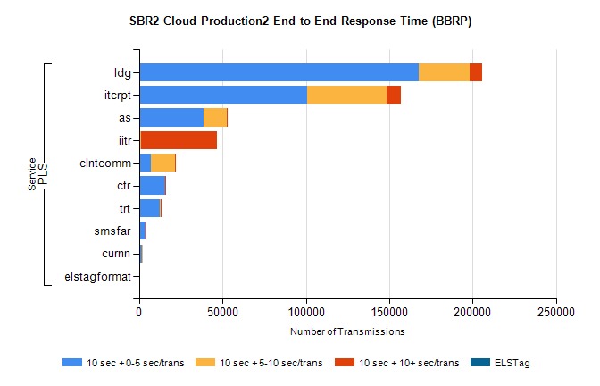
Stream | Service | 10 sec + 0-5 sec /trans | 10 sec + 5-10 sec /trans | 10 sec + >10 sec /trans | Processing Incomplete | ELStag | Total
PLS | ldg | 167447 | 30652 | 7863 | 0 | 0 | 212819
PLS | itcrpt | 100877 | 47786 | 8123 | 0 | 0 | 160579
PLS | as | 38844 | 13726 | 98 | 0 | 0 | 52751
PLS | iitr | 846 | 416 | 45568 | 0 | 0 | 48245
PLS | clntcomm | 7241 | 14124 | 728 | 0 | 0 | 23239
PLS | ctr | 15478 | 256 | 8 | 0 | 0 | 15757
PLS | trt | 12644 | 198 | 6 | 0 | 0 | 12856
PLS | smsfar | 4030 | 91 | 2 | 0 | 0 | 4128
PLS | curnn | 1792 | 402 | 0 | 0 | 0 | 2197
PLS | elstagformat | 260 | 210 | 0 | 0 | 0 | 470

SBR2 Cloud Production2 - Single | Bulk or Batch Requests | (SRP, BBRP & CHiRPP)

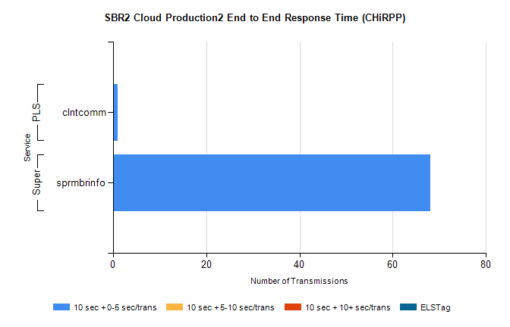
Stream | Service | 10 sec + 0-5 sec /trans | 10 sec + 5-10 sec /trans | 10 sec + >10 sec /trans | Total | % within 5 sec timing target
Super | sprmbrinfo | 68 | 0 | 0 | 68 | 100.0%
PLS | clntcomm | 1 | 0 | 0 | 1 | 100.0%

SBR1 Production Transactions

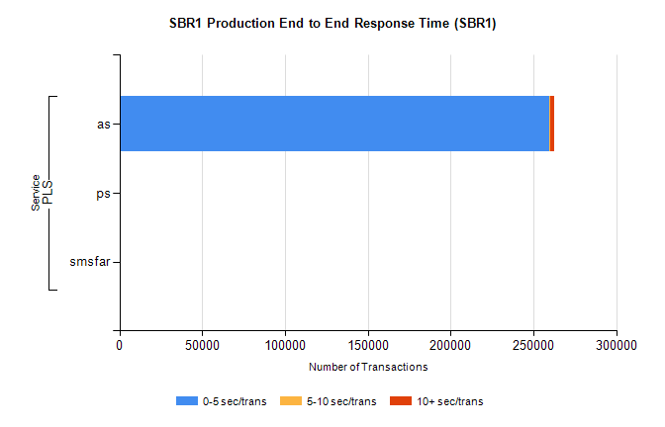
Stream | Service | 0-5 sec/trans | 5-10 sec/trans | 10+ sec/trans | Total | % within 5 sec timing target
PLS | as | 259839 | 273 | 2199 | 262311 | 99.1%
PLS | ps | 18 | 17 | 95 | 130 | 13.8%
PLS | smsfar | 2 | 9 | 1 | 12 | 16.7%

