Transmission Timings Report Week - 16
13/04/2026 - 19/04/2026

SBR2 External Vendor Testing Environment (EVTE3)

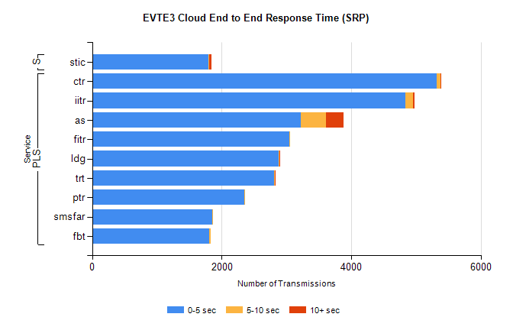
Stream | Service | 0-5 sec | 5-10 sec | >10 sec | Total | % within 5 sec timing target
PLS | ctr | 5320 | 55 | 3 | 5400 | 98.5%
PLS | iitr | 4839 | 118 | 16 | 5008 | 96.6%
PLS | as | 3221 | 390 | 272 | 3971 | 81.1%
PLS | fitr | 3040 | 7 | 0 | 3051 | 99.6%
PLS | ldg | 2876 | 13 | 1 | 2947 | 97.6%
PLS | trt | 2811 | 15 | 1 | 2850 | 98.6%
PLS | ptr | 2351 | 3 | 0 | 2364 | 99.5%
PLS | smsfar | 1850 | 1 | 0 | 1852 | 99.9%
PLS | fbt | 1809 | 27 | 0 | 1839 | 98.4%
Super | stic | 1799 | 5 | 36 | 1908 | 94.3%

SBR2 External Vendor Testing Environment (EVTE3)

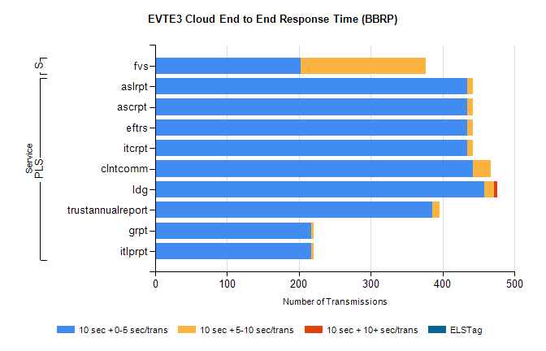
Stream | Service | 10 sec + 0-5 sec /trans | 10 sec + 5-10 sec /trans | 10 sec + >10 sec /trans | Processing Incomplete | ELStag | Total
PLS | itcrpt | 434 | 8 | 0 | 250 | 0 | 692
PLS | eftrs | 434 | 8 | 0 | 250 | 0 | 692
PLS | ascrpt | 434 | 8 | 0 | 250 | 0 | 692
PLS | aslrpt | 434 | 8 | 0 | 250 | 0 | 692
PLS | clntcomm | 442 | 25 | 0 | 96 | 0 | 571
PLS | ldg | 458 | 14 | 4 | 38 | 0 | 522
PLS | trustannualreport | 385 | 11 | 0 | 0 | 0 | 396
PLS | itlprpt | 217 | 4 | 0 | 125 | 0 | 346
PLS | grpt | 217 | 4 | 0 | 125 | 0 | 346
Super | fvs | 202 | 174 | 0 | 63 | 0 | 443

SBR2 External Vendor Testing Environment (EVTE3)

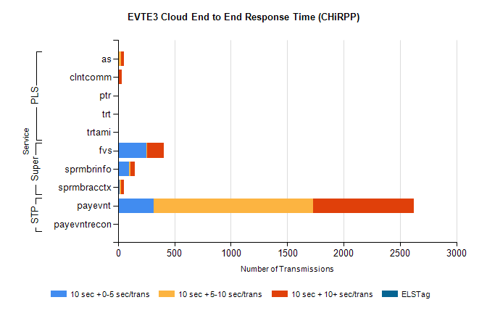
Stream | Service | 10 sec + 0-5 sec /trans | 10 sec + 5-10 sec /trans | 10 sec + >10 sec /trans | Total | % within 5 sec timing target
STP | payevnt | 317 | 1410 | 895 | 3854 | 8.2%
STP | payevntrecon | 0 | 0 | 1 | 1 | 0.0%
Super | fvs | 251 | 4 | 150 | 540 | 46.5%
Super | sprmbrinfo | 97 | 11 | 40 | 160 | 60.6%
Super | sprmbracctx | 15 | 13 | 27 | 82 | 18.3%
PLS | as | 3 | 25 | 27 | 78 | 3.8%
PLS | clntcomm | 0 | 0 | 30 | 35 | 0.0%
PLS | ptr | 0 | 0 | 7 | 7 | 0.0%
PLS | trtami | 0 | 0 | 6 | 6 | 0.0%
PLS | trt | 0 | 0 | 6 | 6 | 0.0%

