Transmission Timings Report Week - 16
13/04/2026 - 19/04/2026

SBR2 Cloud Production2 - Single | Bulk or Batch Requests | (SRP, BBRP & CHiRPP)

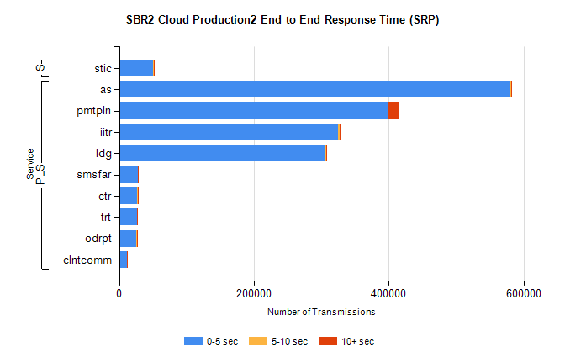
Stream | Service | 0-5 sec | 5-10 sec | >10 sec | Total | % within 5 sec timing target
PLS | as | 580445 | 684 | 422 | 581551 | 99.8%
PLS | pmtpln | 398654 | 615 | 16374 | 415643 | 95.9%
PLS | iitr | 325128 | 1872 | 675 | 327675 | 99.2%
PLS | ldg | 306162 | 523 | 1590 | 308275 | 99.3%
PLS | smsfar | 28307 | 52 | 36 | 28395 | 99.7%
PLS | ctr | 27135 | 54 | 27 | 27216 | 99.7%
PLS | trt | 26828 | 56 | 41 | 26925 | 99.6%
PLS | odrpt | 25698 | 358 | 269 | 26325 | 97.6%
PLS | clntcomm | 11957 | 53 | 11 | 12021 | 99.5%
Super | stic | 50833 | 218 | 1542 | 52593 | 96.7%

SBR2 Cloud Production2 - Single | Bulk or Batch Requests | (SRP, BBRP & CHiRPP)

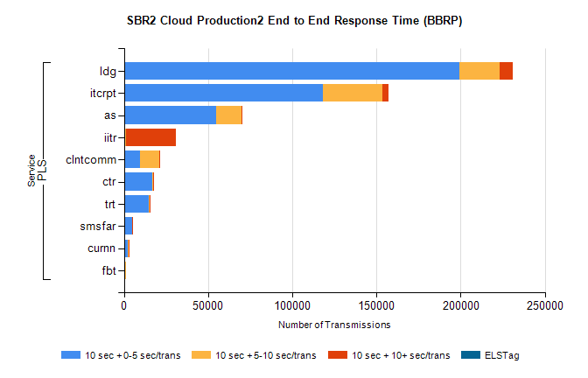
Stream | Service | 10 sec + 0-5 sec /trans | 10 sec + 5-10 sec /trans | 10 sec + >10 sec /trans | Processing Incomplete | ELStag | Total
PLS | ldg | 199450 | 23678 | 7590 | 0 | 0 | 237114
PLS | itcrpt | 118030 | 35599 | 3245 | 0 | 0 | 160074
PLS | as | 54605 | 15439 | 114 | 0 | 0 | 70398
PLS | iitr | 720 | 711 | 29275 | 0 | 0 | 31812
PLS | clntcomm | 9758 | 11096 | 614 | 0 | 0 | 22237
PLS | ctr | 16748 | 490 | 46 | 0 | 0 | 17331
PLS | trt | 14828 | 337 | 27 | 0 | 0 | 15232
PLS | smsfar | 4802 | 160 | 3 | 0 | 0 | 4980
PLS | curnn | 2421 | 492 | 7 | 0 | 0 | 2941
PLS | fbt | 684 | 29 | 0 | 0 | 0 | 716

SBR2 Cloud Production2 - Single | Bulk or Batch Requests | (SRP, BBRP & CHiRPP)

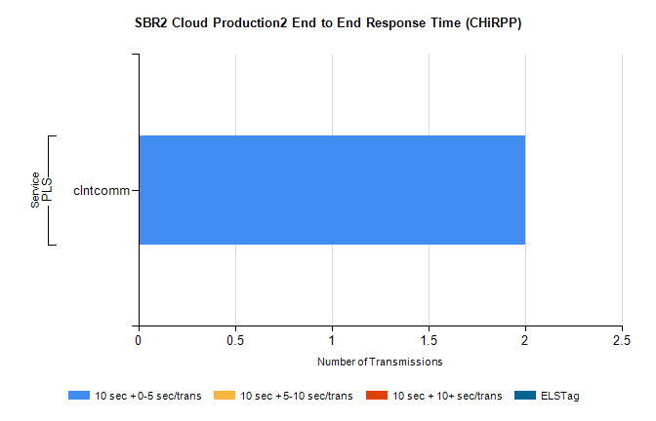
Stream | Service | 10 sec + 0-5 sec /trans | 10 sec + 5-10 sec /trans | 10 sec + >10 sec /trans | Total | % within 5 sec timing target
PLS | clntcomm | 2 | 0 | 0 | 2 | 100.0%

SBR1 Production Transactions

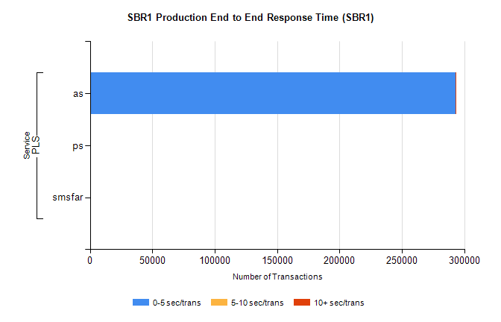
Stream | Service | 0-5 sec/trans | 5-10 sec/trans | 10+ sec/trans | Total | % within 5 sec timing target
PLS | as | 292867 | 210 | 146 | 293223 | 99.9%
PLS | ps | 23 | 31 | 97 | 151 | 15.2%
PLS | smsfar |  | 17 |  | 17 | 0.0%

