Transmission Timings Report Week - 17
20/04/2026 - 26/04/2026

SBR2 External Vendor Testing Environment (EVTE3)

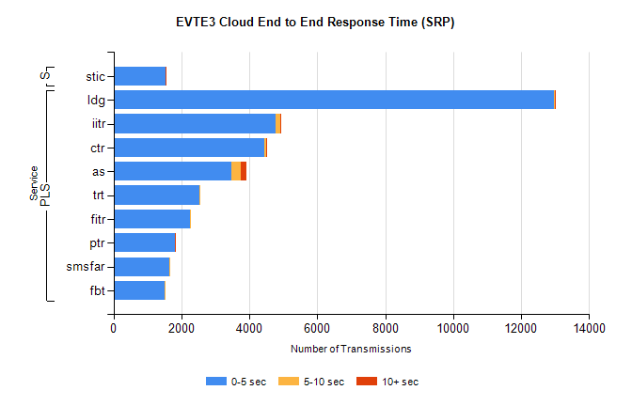
Stream | Service | 0-5 sec | 5-10 sec | >10 sec | Total | % within 5 sec timing target
PLS | ldg | 12982 | 10 | 8 | 13038 | 99.6%
PLS | iitr | 4778 | 124 | 9 | 4920 | 97.1%
PLS | ctr | 4449 | 47 | 1 | 4502 | 98.8%
PLS | as | 3466 | 294 | 164 | 3965 | 87.4%
PLS | trt | 2532 | 4 | 0 | 2546 | 99.5%
PLS | fitr | 2265 | 1 | 0 | 2277 | 99.5%
PLS | ptr | 1817 | 4 | 1 | 1824 | 99.6%
PLS | smsfar | 1647 | 2 | 0 | 1649 | 99.9%
PLS | fbt | 1498 | 17 | 0 | 1515 | 98.9%
Super | stic | 1527 | 3 | 8 | 1538 | 99.3%

SBR2 External Vendor Testing Environment (EVTE3)

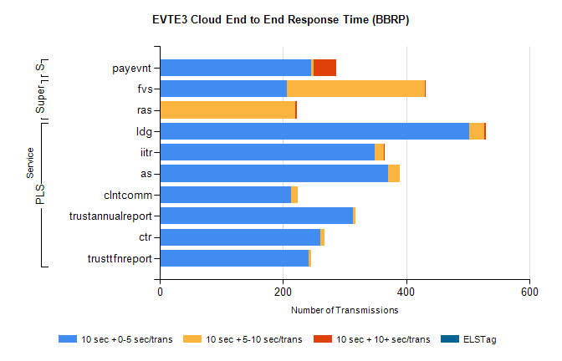
Stream | Service | 10 sec + 0-5 sec /trans | 10 sec + 5-10 sec /trans | 10 sec + >10 sec /trans | Processing Incomplete | ELStag | Total
PLS | ldg | 502 | 24 | 3 | 31 | 0 | 571
PLS | as | 370 | 19 | 0 | 40 | 0 | 429
PLS | iitr | 348 | 16 | 1 | 54 | 0 | 429
PLS | clntcomm | 213 | 11 | 0 | 140 | 0 | 364
PLS | trustannualreport | 313 | 5 | 0 | 0 | 0 | 318
PLS | ctr | 260 | 7 | 0 | 0 | 0 | 269
PLS | trusttfnreport | 242 | 4 | 0 | 0 | 0 | 246
Super | fvs | 206 | 224 | 1 | 15 | 0 | 460
Super | ras | 0 | 220 | 2 | 0 | 0 | 235
STP | payevnt | 245 | 5 | 36 | 45 | 0 | 334

SBR2 External Vendor Testing Environment (EVTE3)

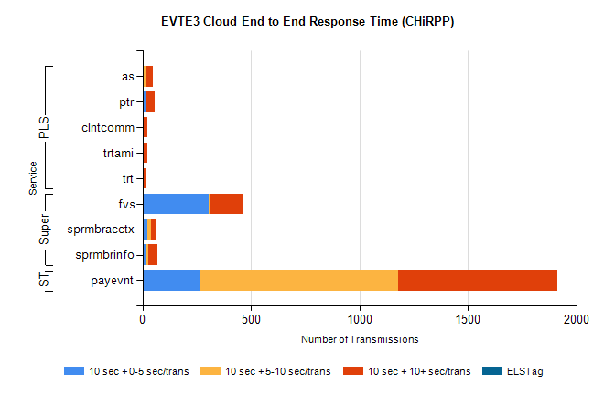
Stream | Service | 10 sec + 0-5 sec /trans | 10 sec + 5-10 sec /trans | 10 sec + >10 sec /trans | Total | % within 5 sec timing target
STP | payevnt | 268 | 910 | 734 | 2864 | 9.4%
Super | fvs | 306 | 9 | 151 | 608 | 50.3%
Super | sprmbracctx | 23 | 14 | 29 | 81 | 28.4%
Super | sprmbrinfo | 13 | 13 | 42 | 76 | 17.1%
PLS | as | 2 | 16 | 29 | 66 | 3.0%
PLS | ptr | 12 | 4 | 39 | 55 | 21.8%
PLS | clntcomm | 0 | 0 | 22 | 22 | 0.0%
PLS | trtami | 0 | 2 | 18 | 20 | 0.0%
PLS | trt | 0 | 3 | 14 | 17 | 0.0%

