Transmission Timings Report Week - 17
20/04/2026 - 26/04/2026

SBR2 Cloud Production2 - Single | Bulk or Batch Requests | (SRP, BBRP & CHiRPP)

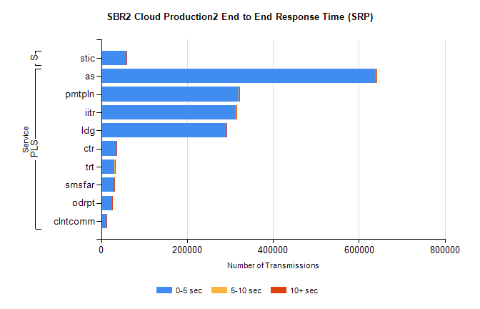
Stream | Service | 0-5 sec | 5-10 sec | >10 sec | Total | % within 5 sec timing target
PLS | as | 639362 | 1388 | 97 | 640847 | 99.8%
PLS | pmtpln | 320315 | 1038 | 112 | 321465 | 99.6%
PLS | iitr | 312422 | 2240 | 306 | 314968 | 99.2%
PLS | ldg | 291429 | 565 | 90 | 292084 | 99.8%
PLS | ctr | 35342 | 79 | 10 | 35431 | 99.7%
PLS | trt | 31232 | 82 | 13 | 31327 | 99.7%
PLS | smsfar | 30443 | 67 | 13 | 30523 | 99.7%
PLS | odrpt | 25928 | 328 | 322 | 26578 | 97.6%
PLS | clntcomm | 12399 | 126 | 18 | 12543 | 98.9%
Super | stic | 58761 | 240 | 56 | 59057 | 99.5%

SBR2 Cloud Production2 - Single | Bulk or Batch Requests | (SRP, BBRP & CHiRPP)

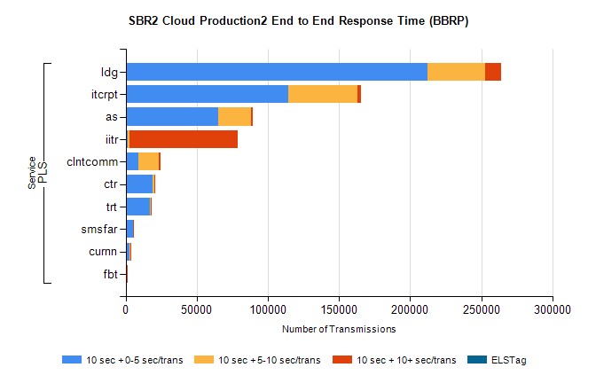
Stream | Service | 10 sec + 0-5 sec /trans | 10 sec + 5-10 sec /trans | 10 sec + >10 sec /trans | Processing Incomplete | ELStag | Total
PLS | ldg | 212137 | 40758 | 11278 | 0 | 0 | 271231
PLS | itcrpt | 114244 | 48594 | 2523 | 0 | 0 | 167551
PLS | as | 65228 | 23087 | 1026 | 0 | 0 | 89602
PLS | iitr | 1380 | 1459 | 75745 | 0 | 0 | 81928
PLS | clntcomm | 9090 | 14192 | 977 | 0 | 0 | 25470
PLS | ctr | 19096 | 757 | 203 | 0 | 0 | 20112
PLS | trt | 17140 | 601 | 179 | 0 | 0 | 17959
PLS | smsfar | 5047 | 189 | 60 | 0 | 0 | 5308
PLS | curnn | 2719 | 639 | 30 | 0 | 0 | 3395
PLS | fbt | 1043 | 61 | 11 | 0 | 0 | 1122

SBR2 Cloud Production2 - Single | Bulk or Batch Requests | (SRP, BBRP & CHiRPP)

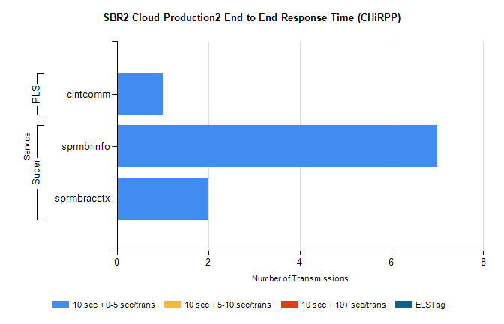
Stream | Service | 10 sec + 0-5 sec /trans | 10 sec + 5-10 sec /trans | 10 sec + >10 sec /trans | Total | % within 5 sec timing target
Super | sprmbrinfo | 7 | 0 | 0 | 7 | 100.0%
Super | sprmbracctx | 2 | 0 | 0 | 2 | 100.0%
PLS | clntcomm | 1 | 0 | 0 | 1 | 100.0%

SBR1 Production Transactions

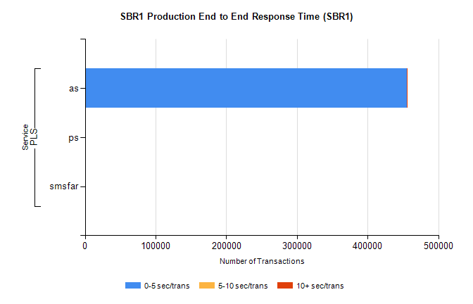
Stream | Service | 0-5 sec/trans | 5-10 sec/trans | 10+ sec/trans | Total | % within 5 sec timing target
PLS | as | 455187 | 158 | 158 | 455503 | 99.9%
PLS | ps | 5 | 6 | 92 | 103 | 4.9%
PLS | smsfar | 1 | 10 |  | 11 | 9.1%

