Transmission Timings Report Week - 18
27/04/2026 - 3/05/2026

SBR2 External Vendor Testing Environment (EVTE3)

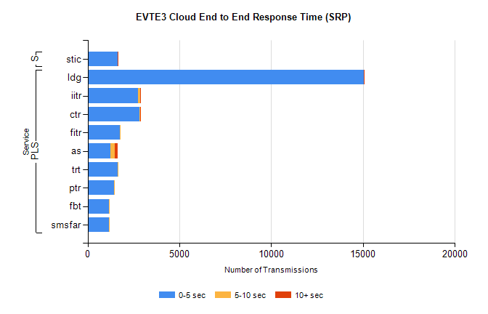
Stream | Service | 0-5 sec | 5-10 sec | >10 sec | Total | % within 5 sec timing target
PLS | ldg | 15038 | 17 | 1 | 15067 | 99.8%
PLS | iitr | 2749 | 114 | 14 | 2878 | 95.5%
PLS | ctr | 2810 | 40 | 4 | 2859 | 98.3%
PLS | fitr | 1738 | 1 | 0 | 1739 | 99.9%
PLS | as | 1236 | 264 | 156 | 1672 | 73.9%
PLS | trt | 1626 | 5 | 0 | 1653 | 98.4%
PLS | ptr | 1440 | 6 | 0 | 1446 | 99.6%
PLS | fbt | 1169 | 17 | 0 | 1186 | 98.6%
PLS | smsfar | 1168 | 5 | 0 | 1173 | 99.6%
Super | stic | 1639 | 5 | 1 | 1645 | 99.6%

SBR2 External Vendor Testing Environment (EVTE3)

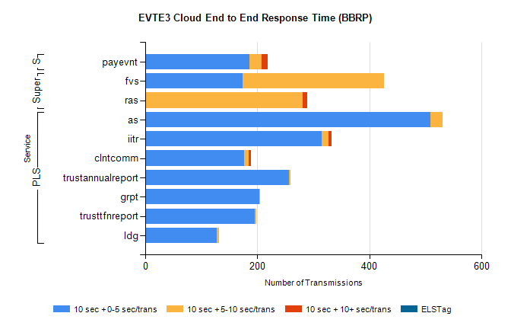
Stream | Service | 10 sec + 0-5 sec /trans | 10 sec + 5-10 sec /trans | 10 sec + >10 sec /trans | Processing Incomplete | ELStag | Total
PLS | as | 509 | 21 | 0 | 82 | 0 | 613
PLS | iitr | 315 | 12 | 5 | 38 | 0 | 379
PLS | clntcomm | 176 | 9 | 3 | 120 | 0 | 313
PLS | trustannualreport | 256 | 3 | 0 | 0 | 0 | 259
PLS | grpt | 203 | 2 | 0 | 0 | 0 | 206
PLS | trusttfnreport | 196 | 2 | 0 | 0 | 0 | 198
PLS | ldg | 127 | 4 | 0 | 9 | 0 | 143
Super | fvs | 174 | 252 | 0 | 5 | 0 | 436
Super | ras | 0 | 281 | 8 | 0 | 0 | 297
STP | payevnt | 186 | 21 | 12 | 30 | 0 | 256

SBR2 External Vendor Testing Environment (EVTE3)

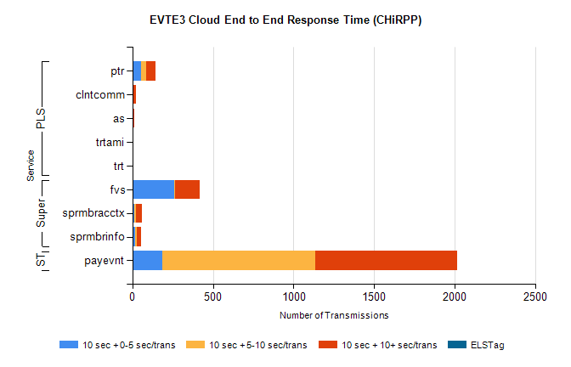
Stream | Service | 10 sec + 0-5 sec /trans | 10 sec + 5-10 sec /trans | 10 sec + >10 sec /trans | Total | % within 5 sec timing target
STP | payevnt | 186 | 950 | 879 | 3120 | 6.0%
Super | fvs | 262 | 2 | 152 | 551 | 47.5%
Super | sprmbracctx | 14 | 10 | 33 | 74 | 18.9%
Super | sprmbrinfo | 18 | 11 | 25 | 63 | 28.6%
PLS | ptr | 53 | 31 | 58 | 147 | 36.1%
PLS | clntcomm | 0 | 0 | 20 | 20 | 0.0%
PLS | as | 0 | 0 | 10 | 11 | 0.0%
PLS | trtami | 0 | 0 | 6 | 6 | 0.0%
PLS | trt | 0 | 0 | 2 | 2 | 0.0%

