Transmission Timings Report Week - 18
27/04/2026 - 3/05/2026

SBR2 Cloud Production2 - Single | Bulk or Batch Requests | (SRP, BBRP & CHiRPP)

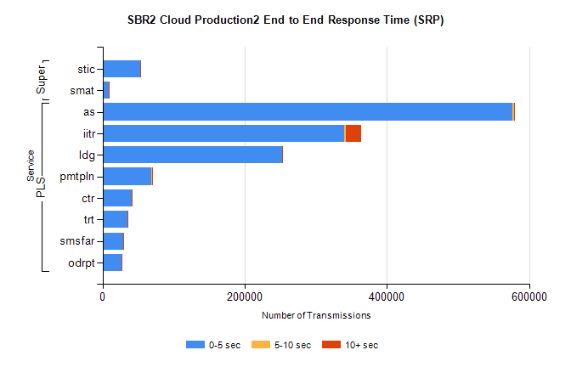
Stream | Service | 0-5 sec | 5-10 sec | >10 sec | Total | % within 5 sec timing target
PLS | as | 577000 | 1626 | 955 | 579581 | 99.6%
PLS | iitr | 339683 | 2859 | 21779 | 364321 | 93.2%
PLS | ldg | 252201 | 687 | 455 | 253343 | 99.5%
PLS | pmtpln | 69197 | 242 | 14 | 69453 | 99.6%
PLS | ctr | 41445 | 138 | 95 | 41678 | 99.4%
PLS | trt | 35276 | 151 | 95 | 35522 | 99.3%
PLS | smsfar | 29632 | 89 | 92 | 29813 | 99.4%
PLS | odrpt | 26657 | 371 | 346 | 27374 | 97.4%
Super | stic | 52598 | 313 | 143 | 53054 | 99.1%
Super | smat | 8679 | 61 | 30 | 8770 | 99.0%

SBR2 Cloud Production2 - Single | Bulk or Batch Requests | (SRP, BBRP & CHiRPP)

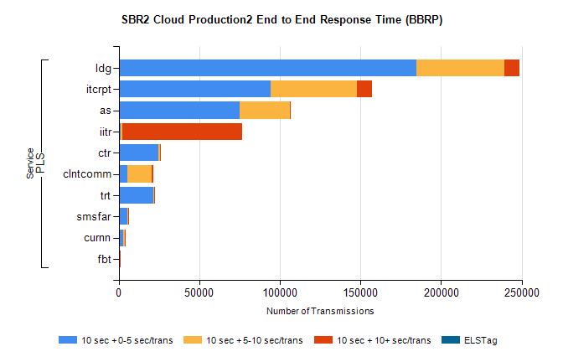
Stream | Service | 10 sec + 0-5 sec /trans | 10 sec + 5-10 sec /trans | 10 sec + >10 sec /trans | Processing Incomplete | ELStag | Total
PLS | ldg | 184810 | 54327 | 9216 | 0 | 0 | 253803
PLS | itcrpt | 94273 | 53659 | 9142 | 0 | 0 | 161853
PLS | as | 75213 | 30846 | 665 | 0 | 0 | 107565
PLS | iitr | 1269 | 1101 | 74168 | 0 | 0 | 80533
PLS | ctr | 24659 | 827 | 55 | 0 | 0 | 25663
PLS | clntcomm | 5337 | 15345 | 652 | 0 | 0 | 22686
PLS | trt | 21434 | 538 | 38 | 0 | 0 | 22107
PLS | smsfar | 5467 | 269 | 10 | 0 | 0 | 5758
PLS | curnn | 2694 | 972 | 13 | 0 | 0 | 3698
PLS | fbt | 549 | 36 | 2 | 0 | 0 | 594

SBR2 Cloud Production2 - Single | Bulk or Batch Requests | (SRP, BBRP & CHiRPP)

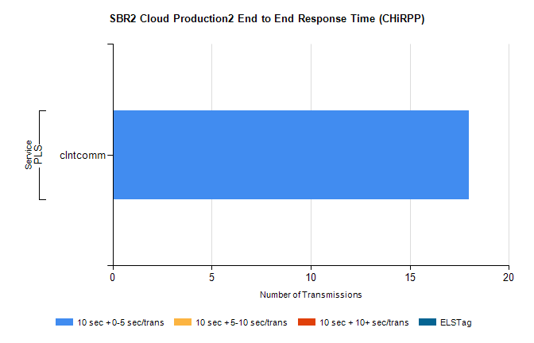
Stream | Service | 10 sec + 0-5 sec /trans | 10 sec + 5-10 sec /trans | 10 sec + >10 sec /trans | Total | % within 5 sec timing target
PLS | clntcomm | 18 | 0 | 0 | 18 | 100.0%

SBR1 Production Transactions

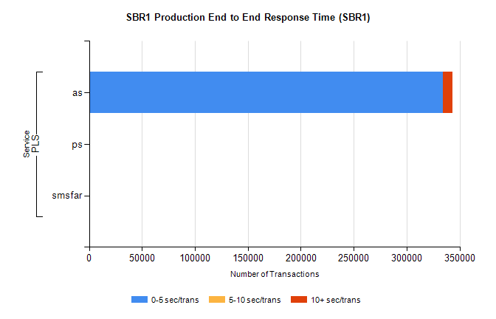
Stream | Service | 0-5 sec/trans | 5-10 sec/trans | 10+ sec/trans | Total | % within 5 sec timing target
PLS | as | 334158 | 268 | 8945 | 343371 | 97.3%
PLS | ps | 48 | 35 | 122 | 205 | 23.4%
PLS | smsfar | 3 | 17 | 8 | 28 | 10.7%

