Transmission Timings Report Week - 19
4/05/2026 - 10/05/2026

SBR2 External Vendor Testing Environment (EVTE3)

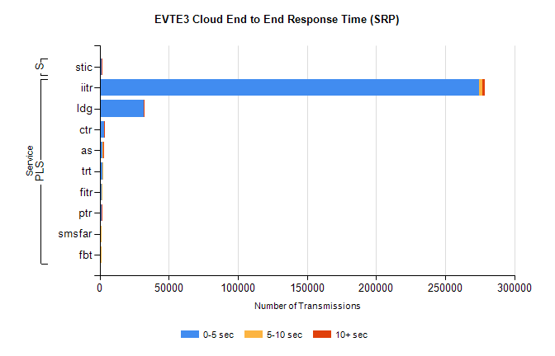
Stream | Service | 0-5 sec | 5-10 sec | >10 sec | Total | % within 5 sec timing target
PLS | iitr | 274622 | 2169 | 1706 | 278501 | 98.6%
PLS | ldg | 32113 | 22 | 3 | 32144 | 99.9%
PLS | ctr | 3085 | 30 | 1 | 3124 | 98.8%
PLS | as | 2226 | 193 | 143 | 2585 | 86.1%
PLS | trt | 1995 | 19 | 0 | 2040 | 97.8%
PLS | fitr | 1414 | 4 | 0 | 1439 | 98.3%
PLS | ptr | 1218 | 11 | 1 | 1251 | 97.4%
PLS | smsfar | 995 | 5 | 0 | 1000 | 99.5%
PLS | fbt | 929 | 13 | 0 | 945 | 98.3%
Super | stic | 1329 | 4 | 4 | 1337 | 99.4%

SBR2 External Vendor Testing Environment (EVTE3)

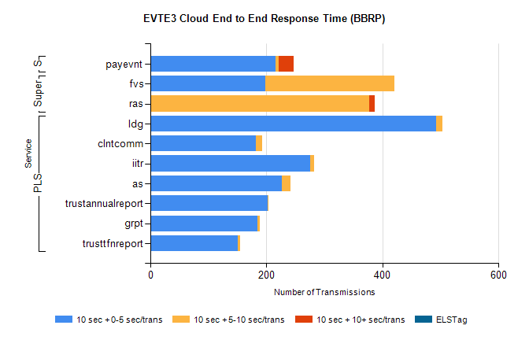
Stream | Service | 10 sec + 0-5 sec /trans | 10 sec + 5-10 sec /trans | 10 sec + >10 sec /trans | Processing Incomplete | ELStag | Total
PLS | ldg | 492 | 11 | 0 | 5 | 0 | 508
PLS | clntcomm | 182 | 11 | 0 | 134 | 0 | 339
PLS | iitr | 275 | 7 | 0 | 32 | 0 | 321
PLS | as | 226 | 15 | 0 | 8 | 0 | 249
PLS | trustannualreport | 202 | 2 | 0 | 0 | 0 | 204
PLS | grpt | 184 | 5 | 0 | 11 | 0 | 200
PLS | trusttfnreport | 150 | 5 | 0 | 0 | 0 | 156
Super | fvs | 198 | 222 | 0 | 9 | 0 | 438
Super | ras | 0 | 377 | 9 | 0 | 0 | 395
STP | payevnt | 216 | 5 | 26 | 52 | 0 | 300

SBR2 External Vendor Testing Environment (EVTE3)

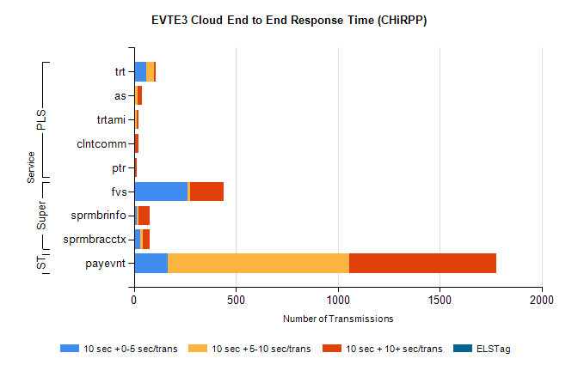
Stream | Service | 10 sec + 0-5 sec /trans | 10 sec + 5-10 sec /trans | 10 sec + >10 sec /trans | Total | % within 5 sec timing target
STP | payevnt | 165 | 892 | 720 | 3155 | 5.2%
Super | fvs | 264 | 11 | 163 | 588 | 44.9%
Super | sprmbrinfo | 12 | 10 | 54 | 93 | 12.9%
Super | sprmbracctx | 31 | 12 | 35 | 92 | 33.7%
PLS | trt | 62 | 36 | 8 | 137 | 45.3%
PLS | as | 1 | 15 | 21 | 46 | 2.2%
PLS | clntcomm | 0 | 0 | 24 | 24 | 0.0%
PLS | trtami | 4 | 11 | 7 | 24 | 16.7%
PLS | ptr | 0 | 3 | 10 | 13 | 0.0%

