Transmission Timings Report Week - 19
4/05/2026 - 10/05/2026

SBR2 Cloud Production2 - Single | Bulk or Batch Requests | (SRP, BBRP & CHiRPP)

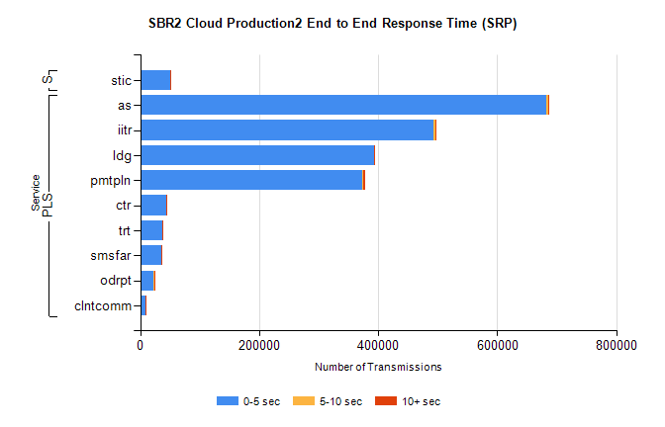
Stream | Service | 0-5 sec | 5-10 sec | >10 sec | Total | % within 5 sec timing target
PLS | as | 682902 | 2314 | 273 | 685489 | 99.6%
PLS | iitr | 493552 | 3120 | 824 | 497496 | 99.2%
PLS | ldg | 392720 | 957 | 1391 | 395068 | 99.4%
PLS | pmtpln | 372617 | 2920 | 3203 | 378740 | 98.4%
PLS | ctr | 43765 | 122 | 23 | 43910 | 99.7%
PLS | trt | 37572 | 129 | 21 | 37722 | 99.6%
PLS | smsfar | 35503 | 113 | 23 | 35639 | 99.6%
PLS | odrpt | 22861 | 421 | 365 | 23647 | 96.7%
PLS | clntcomm | 8992 | 56 | 4 | 9052 | 99.3%
Super | stic | 50883 | 196 | 117 | 51196 | 99.4%

SBR2 Cloud Production2 - Single | Bulk or Batch Requests | (SRP, BBRP & CHiRPP)

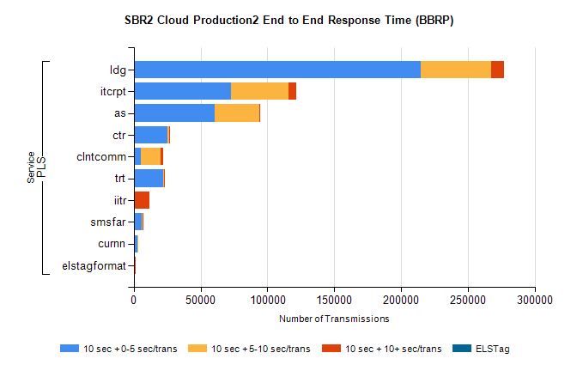
Stream | Service | 10 sec + 0-5 sec /trans | 10 sec + 5-10 sec /trans | 10 sec + >10 sec /trans | Processing Incomplete | ELStag | Total
PLS | ldg | 214888 | 52689 | 9462 | 0 | 0 | 285082
PLS | itcrpt | 72770 | 42839 | 6191 | 0 | 0 | 126517
PLS | as | 60654 | 33154 | 148 | 0 | 0 | 94243
PLS | ctr | 25289 | 963 | 24 | 0 | 0 | 26325
PLS | clntcomm | 5171 | 15078 | 1711 | 0 | 0 | 24071
PLS | trt | 21823 | 678 | 16 | 0 | 0 | 22553
PLS | iitr | 436 | 140 | 10997 | 0 | 0 | 11851
PLS | smsfar | 6192 | 260 | 3 | 0 | 0 | 6474
PLS | curnn | 2695 | 883 | 0 | 0 | 0 | 3586
PLS | elstagformat | 287 | 299 | 2 | 0 | 0 | 591

SBR2 Cloud Production2 - Single | Bulk or Batch Requests | (SRP, BBRP & CHiRPP)

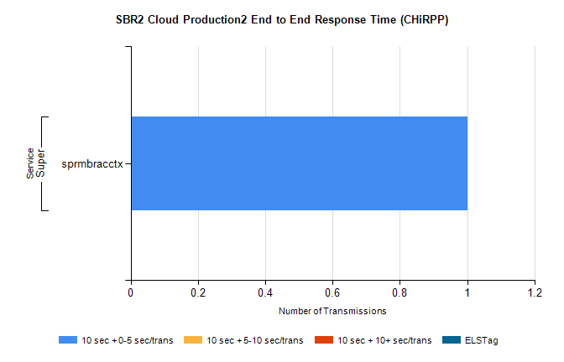
Stream | Service | 10 sec + 0-5 sec /trans | 10 sec + 5-10 sec /trans | 10 sec + >10 sec /trans | Total | % within 5 sec timing target
Super | sprmbracctx | 1 | 0 | 0 | 1 | 100.0%

SBR1 Production Transactions

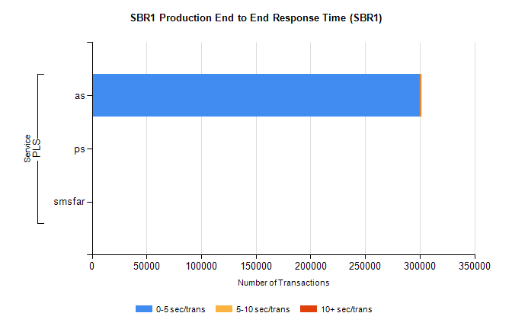
Stream | Service | 0-5 sec/trans | 5-10 sec/trans | 10+ sec/trans | Total | % within 5 sec timing target
PLS | as | 300344 | 260 | 611 | 301215 | 99.7%
PLS | ps | 15 | 16 | 121 | 152 | 9.9%
PLS | smsfar | 3 | 20 |  | 23 | 13.0%

