Transmission Timings Report Week - 20
11/05/2026 - 17/05/2026

SBR2 External Vendor Testing Environment (EVTE3)

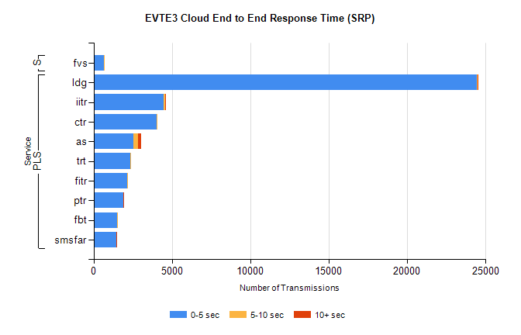
Stream | Service | 0-5 sec | 5-10 sec | >10 sec | Total | % within 5 sec timing target
PLS | ldg | 24466 | 16 | 2 | 24492 | 99.9%
PLS | iitr | 4462 | 94 | 25 | 4586 | 97.3%
PLS | ctr | 4020 | 45 | 0 | 4096 | 98.1%
PLS | as | 2561 | 298 | 196 | 3110 | 82.3%
PLS | trt | 2359 | 14 | 0 | 2377 | 99.2%
PLS | fitr | 2130 | 2 | 0 | 2132 | 99.9%
PLS | ptr | 1900 | 11 | 1 | 1918 | 99.1%
PLS | fbt | 1517 | 33 | 0 | 1559 | 97.3%
PLS | smsfar | 1468 | 8 | 3 | 1479 | 99.3%
Super | fvs | 678 | 1 | 0 | 679 | 99.9%

SBR2 External Vendor Testing Environment (EVTE3)

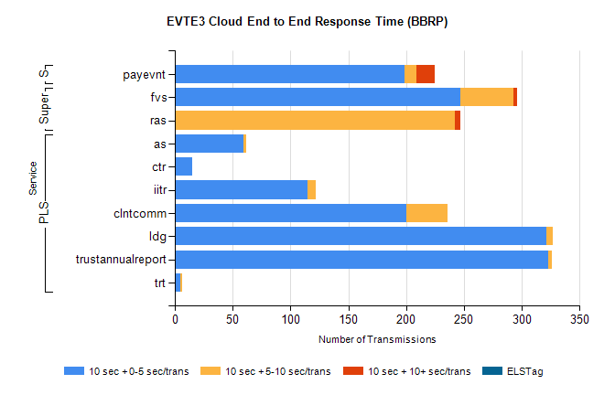
Stream | Service | 10 sec + 0-5 sec /trans | 10 sec + 5-10 sec /trans | 10 sec + >10 sec /trans | Processing Incomplete | ELStag | Total
PLS | as | 59 | 3 | 0 | 690 | 0 | 752
PLS | ctr | 15 | 0 | 0 | 492 | 0 | 507
PLS | iitr | 115 | 7 | 0 | 305 | 0 | 433
PLS | clntcomm | 200 | 36 | 0 | 120 | 0 | 357
PLS | ldg | 321 | 6 | 0 | 4 | 0 | 333
PLS | trustannualreport | 323 | 3 | 0 | 0 | 0 | 326
PLS | trt | 5 | 1 | 0 | 311 | 0 | 317
Super | fvs | 247 | 46 | 3 | 7 | 0 | 307
Super | ras | 0 | 242 | 5 | 0 | 0 | 256
STP | payevnt | 199 | 10 | 16 | 46 | 0 | 275

SBR2 External Vendor Testing Environment (EVTE3)

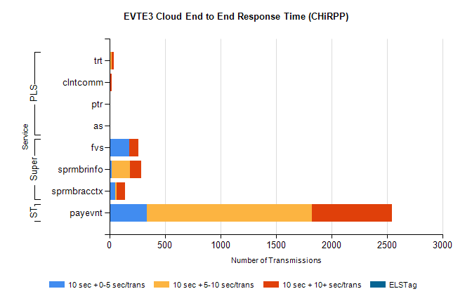
Stream | Service | 10 sec + 0-5 sec /trans | 10 sec + 5-10 sec /trans | 10 sec + >10 sec /trans | Total | % within 5 sec timing target
STP | payevnt | 335 | 1490 | 718 | 3721 | 9.0%
Super | fvs | 178 | 2 | 81 | 514 | 50.9%
Super | sprmbrinfo | 20 | 166 | 101 | 326 | 6.1%
Super | sprmbracctx | 51 | 16 | 75 | 188 | 27.1%
PLS | trt | 0 | 20 | 20 | 43 | 0.0%
PLS | clntcomm | 0 | 0 | 18 | 18 | 0.0%
PLS | ptr | 1 | 0 | 6 | 8 | 12.5%
PLS | as | 0 | 0 | 4 | 4 | 0.0%

