Transmission Timings Report Week - 20
11/05/2026 - 17/05/2026

SBR2 Cloud Production2 - Single | Bulk or Batch Requests | (SRP, BBRP & CHiRPP)

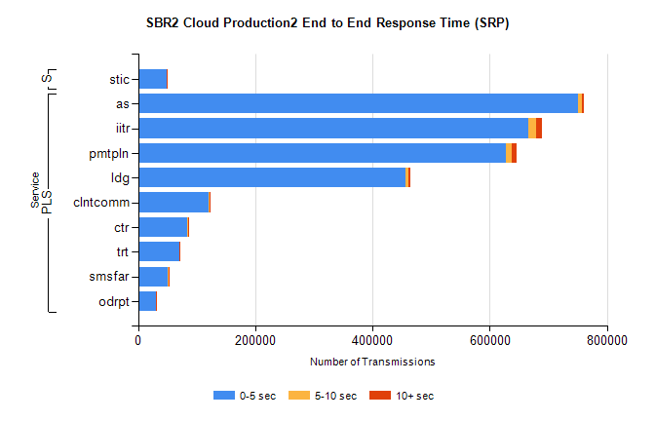
Stream | Service | 0-5 sec | 5-10 sec | >10 sec | Total | % within 5 sec timing target
PLS | as | 751330 | 5845 | 4153 | 761328 | 98.7%
PLS | iitr | 665826 | 13418 | 10248 | 689492 | 96.6%
PLS | pmtpln | 627946 | 9861 | 8601 | 646408 | 97.1%
PLS | ldg | 456919 | 4781 | 3582 | 465282 | 98.2%
PLS | clntcomm | 120698 | 823 | 298 | 121819 | 99.1%
PLS | ctr | 83677 | 974 | 704 | 85355 | 98.0%
PLS | trt | 69981 | 827 | 694 | 71502 | 97.9%
PLS | smsfar | 50647 | 772 | 493 | 51912 | 97.6%
PLS | odrpt | 30057 | 726 | 268 | 31051 | 96.8%
Super | stic | 48195 | 1101 | 916 | 50212 | 96.0%

SBR2 Cloud Production2 - Single | Bulk or Batch Requests | (SRP, BBRP & CHiRPP)

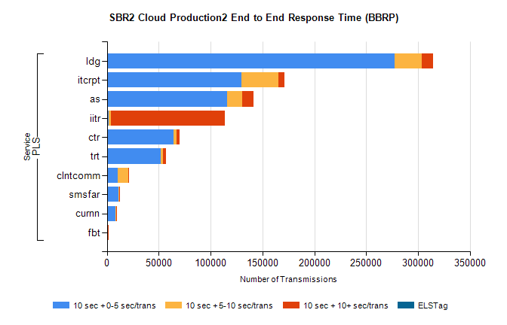
Stream | Service | 10 sec + 0-5 sec /trans | 10 sec + 5-10 sec /trans | 10 sec + >10 sec /trans | Processing Incomplete | ELStag | Total
PLS | ldg | 277350 | 26062 | 10830 | 0 | 0 | 323605
PLS | itcrpt | 129925 | 35276 | 5675 | 0 | 0 | 175961
PLS | as | 115557 | 15017 | 10699 | 0 | 0 | 143352
PLS | iitr | 1750 | 2105 | 109629 | 0 | 0 | 125101
PLS | ctr | 64213 | 3014 | 3092 | 0 | 0 | 71350
PLS | trt | 52228 | 2127 | 2416 | 0 | 0 | 57495
PLS | clntcomm | 10479 | 9860 | 1117 | 0 | 0 | 22835
PLS | smsfar | 11239 | 532 | 283 | 0 | 0 | 12209
PLS | curnn | 7960 | 803 | 470 | 0 | 0 | 9338
PLS | fbt | 726 | 33 | 45 | 0 | 0 | 816

SBR1 Production Transactions

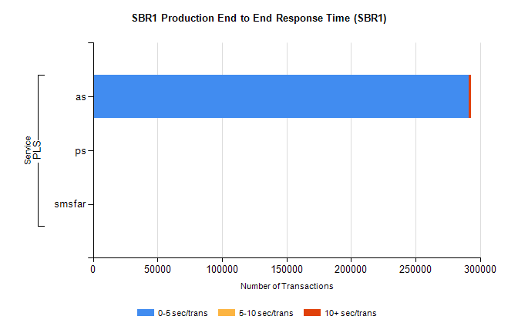
Stream | Service | 0-5 sec/trans | 5-10 sec/trans | 10+ sec/trans | Total | % within 5 sec timing target
PLS | as | 291111 | 265 | 1475 | 292851 | 99.4%
PLS | ps | 58 | 38 | 180 | 276 | 21.0%
PLS | smsfar |  | 11 |  | 11 | 0.0%

