Transmission Timings Report Week - 22
25/05/2026 – 31/05/2026

SBR2 External Vendor Testing Environment (EVTE3)

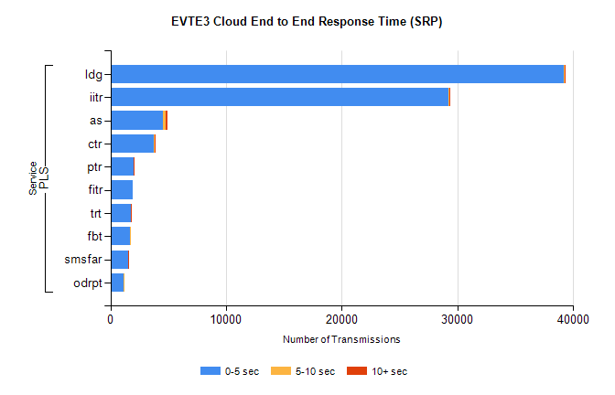
Stream | Service | 0-5 sec | 5-10 sec | >10 sec | Total | % within 5 sec timing target
PLS | ldg | 39210 | 30 | 4 | 39251 | 99.9%
PLS | iitr | 29213 | 122 | 15 | 29355 | 99.5%
PLS | as | 4504 | 263 | 161 | 4941 | 91.2%
PLS | ctr | 3767 | 30 | 4 | 3863 | 97.5%
PLS | ptr | 2022 | 3 | 1 | 2051 | 98.6%
PLS | fitr | 1951 | 0 | 0 | 1960 | 99.5%
PLS | trt | 1805 | 6 | 2 | 1847 | 97.7%
PLS | fbt | 1657 | 26 | 0 | 1691 | 98.0%
PLS | smsfar | 1509 | 7 | 4 | 1543 | 97.8%
PLS | odrpt | 1146 | 5 | 0 | 1151 | 99.6%

SBR2 External Vendor Testing Environment (EVTE3)

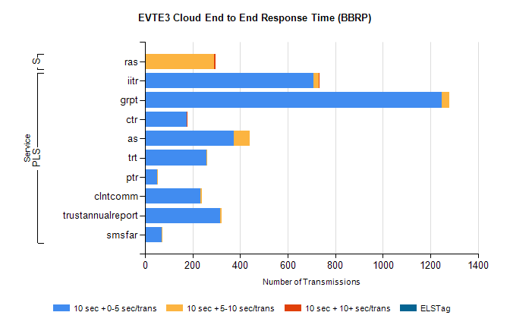
Stream | Service | 10 sec + 0-5 sec /trans | 10 sec + 5-10 sec /trans | 10 sec + >10 sec /trans | Processing Incomplete | ELStag | Total
PLS | iitr | 709 | 22 | 1 | 568 | 0 | 1306
PLS | grpt | 1247 | 34 | 0 | 0 | 0 | 1282
PLS | ctr | 175 | 2 | 1 | 899 | 0 | 1079
PLS | as | 373 | 68 | 0 | 512 | 0 | 957
PLS | trt | 258 | 1 | 0 | 302 | 0 | 561
PLS | ptr | 52 | 2 | 0 | 368 | 0 | 422
PLS | clntcomm | 234 | 5 | 0 | 146 | 0 | 385
PLS | trustannualreport | 315 | 6 | 0 | 0 | 0 | 321
PLS | smsfar | 69 | 5 | 0 | 236 | 0 | 312
Super | ras | 0 | 291 | 6 | 0 | 0 | 310

SBR2 External Vendor Testing Environment (EVTE3)

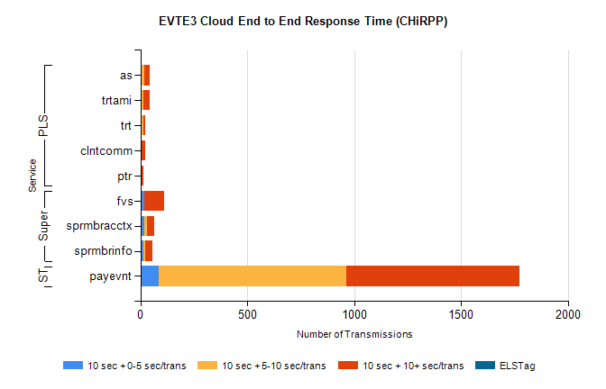
Stream | Service | 10 sec + 0-5 sec /trans | 10 sec + 5-10 sec /trans | 10 sec + >10 sec /trans | Total | % within 5 sec timing target
STP | payevnt | 85 | 880 | 807 | 2735 | 3.1%
Super | fvs | 18 | 0 | 94 | 237 | 7.6%
Super | sprmbracctx | 19 | 13 | 34 | 80 | 23.8%
Super | sprmbrinfo | 14 | 8 | 32 | 71 | 19.7%
PLS | as | 7 | 10 | 25 | 72 | 9.7%
PLS | trtami | 2 | 10 | 29 | 43 | 4.7%
PLS | trt | 2 | 12 | 10 | 27 | 7.4%
PLS | clntcomm | 0 | 0 | 21 | 21 | 0.0%
PLS | ptr | 0 | 4 | 11 | 18 | 0.0%

