Transmission Timings Report Week - 29
13/07/2026 - 19/07/2026

SBR2 Cloud Production2 - Single | Bulk or Batch Requests | (SRP, BBRP & CHiRPP)

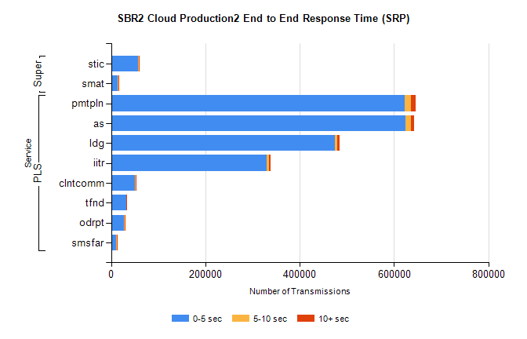
Stream | Service | 0-5 sec | 5-10 sec | >10 sec | Total | % within 5 sec timing target
PLS | pmtpln | 622981 | 13109 | 9559 | 645649 | 96.5%
PLS | as | 624036 | 11488 | 7618 | 643142 | 97.0%
PLS | ldg | 474450 | 5844 | 4146 | 484440 | 97.9%
PLS | iitr | 329232 | 5670 | 3685 | 338587 | 97.2%
PLS | clntcomm | 50864 | 624 | 229 | 51717 | 98.4%
PLS | tfnd | 31533 | 510 | 412 | 32455 | 97.2%
PLS | odrpt | 27673 | 712 | 152 | 28537 | 97.0%
PLS | smsfar | 11272 | 206 | 176 | 11654 | 96.7%
Super | stic | 57652 | 999 | 671 | 59322 | 97.2%
Super | smat | 14436 | 551 | 416 | 15403 | 93.7%

SBR2 Cloud Production2 - Single | Bulk or Batch Requests | (SRP, BBRP & CHiRPP)

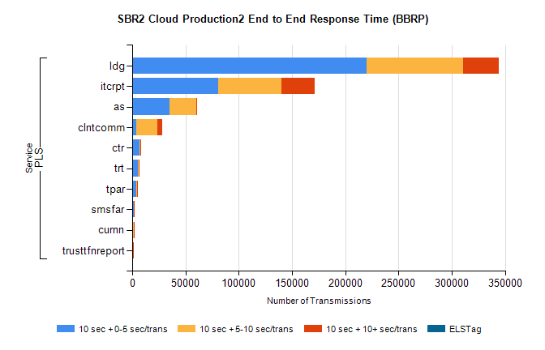
Stream | Service | 10 sec + 0-5 sec /trans | 10 sec + 5-10 sec /trans | 10 sec + >10 sec /trans | Processing Incomplete | ELStag | Total
PLS | ldg | 220012 | 90426 | 33494 | 0 | 0 | 368478
PLS | itcrpt | 80603 | 59236 | 31367 | 0 | 0 | 187858
PLS | as | 35135 | 25443 | 466 | 0 | 0 | 62094
PLS | clntcomm | 4263 | 19130 | 4609 | 0 | 0 | 33421
PLS | ctr | 6684 | 683 | 28 | 0 | 0 | 7476
PLS | trt | 5767 | 550 | 29 | 0 | 0 | 6407
PLS | tpar | 4115 | 544 | 29 | 0 | 0 | 4771
PLS | smsfar | 1464 | 137 | 7 | 0 | 0 | 1634
PLS | curnn | 951 | 446 | 12 | 0 | 0 | 1438
PLS | trusttfnreport | 663 | 62 | 3 | 0 | 0 | 738

SBR1 Production Transactions

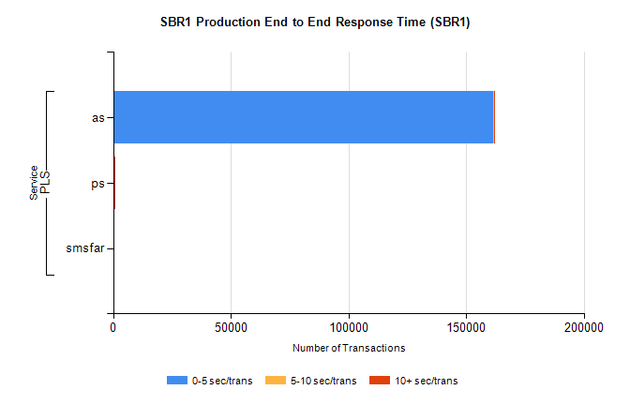
Stream | Service | 0-5 sec/trans | 5-10 sec/trans | 10+ sec/trans | Total | % within 5 sec timing target
PLS | as | 161638 | 425 | 159 | 162222 | 99.6%
PLS | ps | 286 | 160 | 438 | 884 | 32.4%
PLS | smsfar |  | 13 |  | 13 | 0.0%

