Transmission Timings Report Week - 30
20/07/2026 - 26/07/2026

SBR2 Cloud Production2 - Single | Bulk or Batch Requests | (SRP, BBRP & CHiRPP)

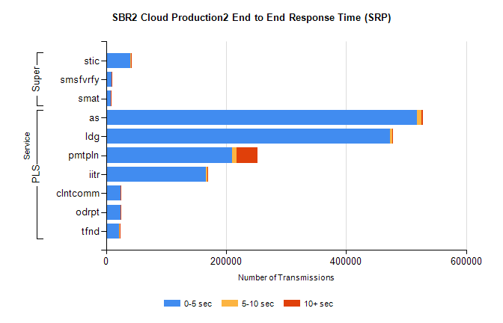
Stream | Service | 0-5 sec | 5-10 sec | >10 sec | Total | % within 5 sec timing target
PLS | as | 518474 | 7608 | 1643 | 527725 | 98.2%
PLS | ldg | 472784 | 3861 | 808 | 477453 | 99.0%
PLS | pmtpln | 210166 | 7017 | 35629 | 252812 | 83.1%
PLS | iitr | 165964 | 2593 | 686 | 169243 | 98.1%
PLS | clntcomm | 23731 | 382 | 44 | 24157 | 98.2%
PLS | odrpt | 23516 | 299 | 218 | 24033 | 97.8%
PLS | tfnd | 22091 | 327 | 68 | 22486 | 98.2%
Super | stic | 40596 | 596 | 125 | 41317 | 98.3%
Super | smsfvrfy | 8987 | 190 | 87 | 9264 | 97.0%
Super | smat | 7468 | 213 | 54 | 7735 | 96.5%

SBR2 Cloud Production2 - Single | Bulk or Batch Requests | (SRP, BBRP & CHiRPP)

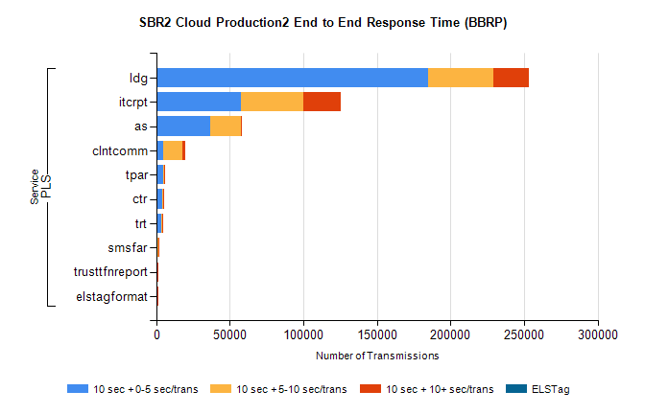
Stream | Service | 10 sec + 0-5 sec /trans | 10 sec + 5-10 sec /trans | 10 sec + >10 sec /trans | Processing Incomplete | ELStag | Total
PLS | ldg | 184674 | 44293 | 24387 | 0 | 0 | 268481
PLS | itcrpt | 57225 | 42556 | 25569 | 0 | 0 | 137284
PLS | as | 36470 | 21183 | 312 | 0 | 0 | 59502
PLS | clntcomm | 4618 | 12976 | 2407 | 0 | 0 | 23387
PLS | tpar | 4493 | 534 | 21 | 0 | 0 | 5087
PLS | ctr | 4194 | 415 | 10 | 0 | 0 | 4649
PLS | trt | 3666 | 354 | 21 | 0 | 0 | 4063
PLS | smsfar | 1006 | 130 | 8 | 0 | 0 | 1151
PLS | trusttfnreport | 618 | 59 | 1 | 0 | 0 | 681
PLS | elstagformat | 244 | 300 | 8 | 0 | 0 | 561

SBR2 Cloud Production2 - Single | Bulk or Batch Requests | (SRP, BBRP & CHiRPP)

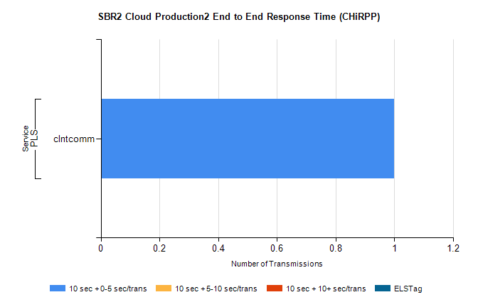
Stream | Service | 10 sec + 0-5 sec /trans | 10 sec + 5-10 sec /trans | 10 sec + >10 sec /trans | Total | % within 5 sec timing target
PLS | clntcomm | 1 | 0 | 0 | 1 | 100.0%

SBR1 Production Transactions

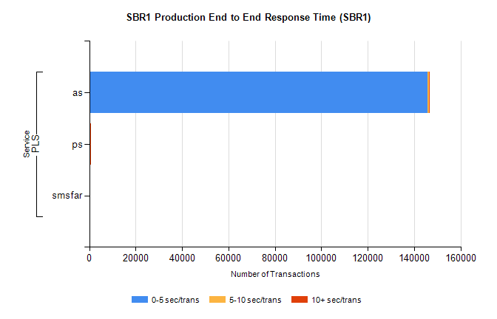
Stream | Service | 0-5 sec/trans | 5-10 sec/trans | 10+ sec/trans | Total | % within 5 sec timing target
PLS | as | 145885 | 575 | 183 | 146643 | 99.5%
PLS | ps | 215 | 106 | 327 | 648 | 33.2%
PLS | smsfar | 1 | 5 |  | 6 | 16.7%

