Transmission Timings Report Week - 31
27/07/2026 - 2/08/2026

SBR2 External Vendor Testing Environment (EVTE3)

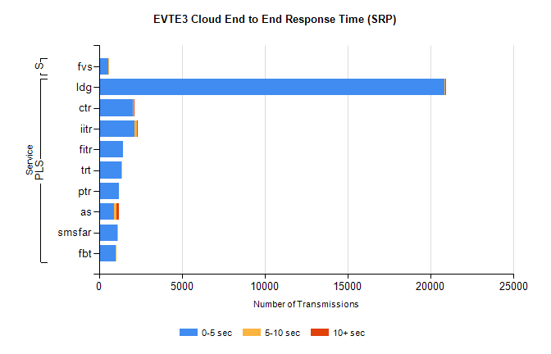
Stream | Service | 0-5 sec | 5-10 sec | >10 sec | Total | % within 5 sec timing target
PLS | ldg | 20843 | 29 | 2 | 26580 | 78.4%
PLS | ctr | 2072 | 48 | 1 | 4319 | 48.0%
PLS | iitr | 2165 | 114 | 19 | 4034 | 53.7%
PLS | fitr | 1443 | 0 | 0 | 2975 | 48.5%
PLS | trt | 1360 | 6 | 0 | 2651 | 51.3%
PLS | ptr | 1225 | 0 | 0 | 2439 | 50.2%
PLS | as | 887 | 184 | 143 | 2225 | 39.9%
PLS | smsfar | 1106 | 4 | 0 | 2178 | 50.8%
PLS | fbt | 988 | 22 | 0 | 1903 | 51.9%
Super | fvs | 554 | 1 | 0 | 825 | 67.2%

SBR2 External Vendor Testing Environment (EVTE3)

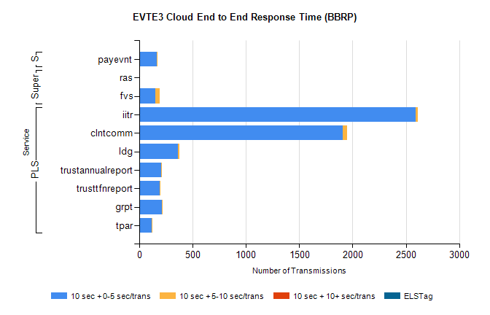
Stream | Service | 10 sec + 0-5 sec /trans | 10 sec + 5-10 sec /trans | 10 sec + >10 sec /trans | Processing Incomplete | ELStag | Total
PLS | iitr | 2591 | 24 | 0 | 480 | 0 | 3096
PLS | clntcomm | 1908 | 43 | 0 | 26 | 0 | 1977
PLS | ldg | 364 | 9 | 0 | 222 | 0 | 596
PLS | trustannualreport | 208 | 1 | 0 | 282 | 0 | 491
PLS | trusttfnreport | 192 | 5 | 0 | 234 | 0 | 431
PLS | grpt | 213 | 1 | 0 | 53 | 0 | 267
PLS | tpar | 117 | 6 | 0 | 61 | 0 | 188
Super | ras | 0 | 0 | 0 | 327 | 0 | 327
Super | fvs | 153 | 39 | 0 | 29 | 0 | 221
STP | payevnt | 161 | 1 | 0 | 85 | 0 | 247

SBR2 External Vendor Testing Environment (EVTE3)

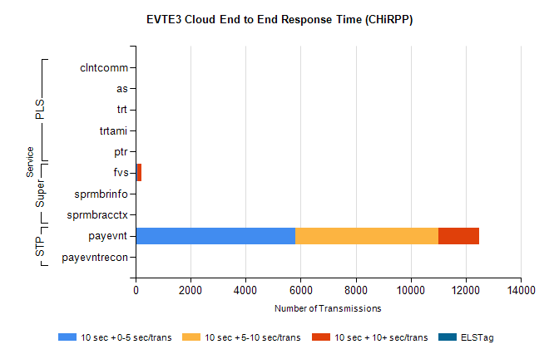
Stream | Service | 10 sec + 0-5 sec /trans | 10 sec + 5-10 sec /trans | 10 sec + >10 sec /trans | Total | % within 5 sec timing target
STP | payevnt | 5811 | 5181 | 1486 | 30322 | 40.6%
STP | payevntrecon | 0 | 0 | 0 | 2958 | NaN
Super | fvs | 66 | 2 | 143 | 453 | 16.8%
Super | sprmbrinfo | 0 | 0 | 0 | 122 | NaN
Super | sprmbracctx | 0 | 0 | 0 | 107 | NaN
PLS | clntcomm | 0 | 0 | 0 | 60 | NaN
PLS | as | 0 | 0 | 0 | 51 | NaN
PLS | trt | 0 | 0 | 0 | 5 | NaN
PLS | ptr | 0 | 0 | 0 | 1 | NaN
PLS | trtami | 0 | 0 | 0 | 1 | NaN

