Transmission Timings Report Week - 32
3/08/2026 - 9/08/2026

SBR2 External Vendor Testing Environment (EVTE3)

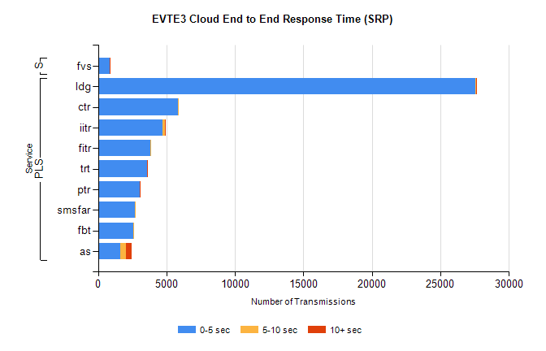
Stream | Service | 0-5 sec | 5-10 sec | >10 sec | Total | % within 5 sec timing target
PLS | ldg | 27576 | 23 | 2 | 27601 | 99.9%
PLS | ctr | 5813 | 38 | 0 | 5863 | 99.1%
PLS | iitr | 4742 | 144 | 5 | 4911 | 96.6%
PLS | fitr | 3831 | 1 | 0 | 3833 | 99.9%
PLS | trt | 3600 | 12 | 2 | 3616 | 99.6%
PLS | ptr | 3071 | 4 | 1 | 3081 | 99.7%
PLS | smsfar | 2725 | 3 | 0 | 2728 | 99.9%
PLS | fbt | 2589 | 42 | 0 | 2633 | 98.3%
PLS | as | 1612 | 432 | 421 | 2479 | 65.0%
Super | fvs | 869 | 3 | 1 | 873 | 99.5%

SBR2 External Vendor Testing Environment (EVTE3)

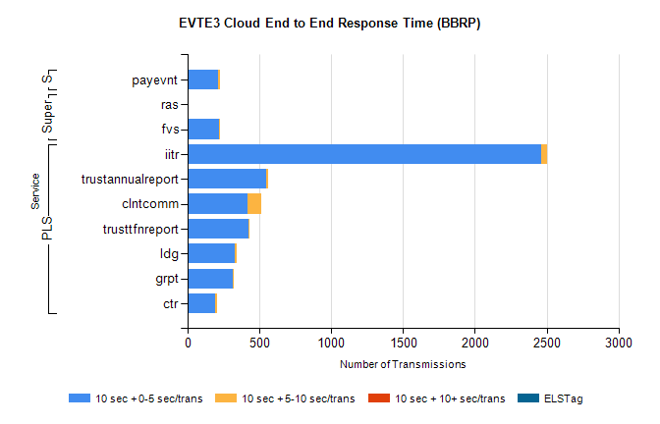
Stream | Service | 10 sec + 0-5 sec /trans | 10 sec + 5-10 sec /trans | 10 sec + >10 sec /trans | Processing Incomplete | ELStag | Total
PLS | iitr | 2465 | 40 | 0 | 0 | 0 | 2512
PLS | trustannualreport | 550 | 8 | 0 | 0 | 0 | 558
PLS | clntcomm | 420 | 92 | 0 | 0 | 0 | 514
PLS | trusttfnreport | 423 | 4 | 0 | 0 | 0 | 431
PLS | ldg | 326 | 16 | 0 | 0 | 0 | 343
PLS | grpt | 313 | 4 | 0 | 0 | 0 | 317
PLS | ctr | 188 | 17 | 0 | 0 | 0 | 206
Super | ras | 0 | 0 | 0 | 322 | 0 | 322
Super | fvs | 221 | 5 | 0 | 0 | 0 | 226
STP | payevnt | 213 | 14 | 0 | 0 | 0 | 229

SBR2 External Vendor Testing Environment (EVTE3)

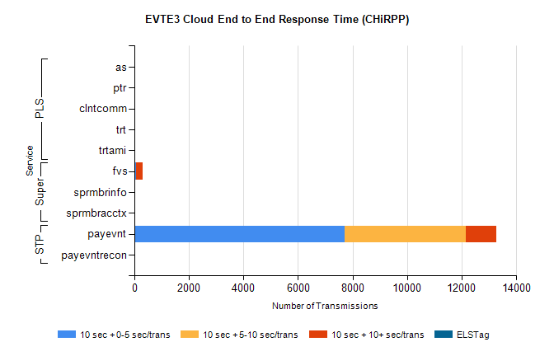
Stream | Service | 10 sec + 0-5 sec /trans | 10 sec + 5-10 sec /trans | 10 sec + >10 sec /trans | Total | % within 5 sec timing target
STP | payevnt | 7720 | 4429 | 1113 | 14485 | 53.3%
STP | payevntrecon | 0 | 0 | 0 | 300 | NaN
Super | fvs | 78 | 0 | 238 | 475 | 16.4%
Super | sprmbrinfo | 0 | 0 | 0 | 191 | NaN
Super | sprmbracctx | 0 | 0 | 0 | 152 | NaN
PLS | as | 11 | 0 | 0 | 162 | 100.0%
PLS | ptr | 0 | 0 | 0 | 62 | NaN
PLS | clntcomm | 0 | 0 | 0 | 54 | NaN
PLS | trt | 0 | 0 | 0 | 35 | NaN
PLS | trtami | 0 | 0 | 0 | 4 | NaN

