Transmission Timings Report Week - 32
3/08/2026 - 9/08/2026

SBR2 Cloud Production2 - Single | Bulk or Batch Requests | (SRP, BBRP & CHiRPP)

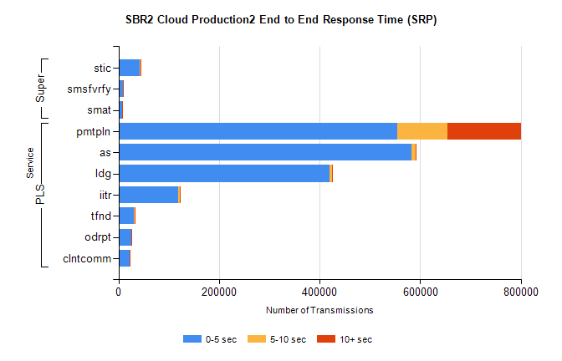
Stream | Service | 0-5 sec | 5-10 sec | >10 sec | Total | % within 5 sec timing target
PLS | pmtpln | 554369 | 99406 | 146163 | 799938 | 69.3%
PLS | as | 583050 | 8556 | 1767 | 593373 | 98.3%
PLS | ldg | 419370 | 4742 | 788 | 424900 | 98.7%
PLS | iitr | 119245 | 2157 | 651 | 122053 | 97.7%
PLS | tfnd | 30827 | 464 | 82 | 31373 | 98.3%
PLS | odrpt | 24752 | 399 | 67 | 25218 | 98.2%
PLS | clntcomm | 22121 | 500 | 57 | 22678 | 97.5%
Super | stic | 42854 | 502 | 89 | 43445 | 98.6%
Super | smsfvrfy | 8572 | 162 | 55 | 8789 | 97.5%
Super | smat | 7706 | 245 | 46 | 7997 | 96.4%

SBR2 Cloud Production2 - Single | Bulk or Batch Requests | (SRP, BBRP & CHiRPP)

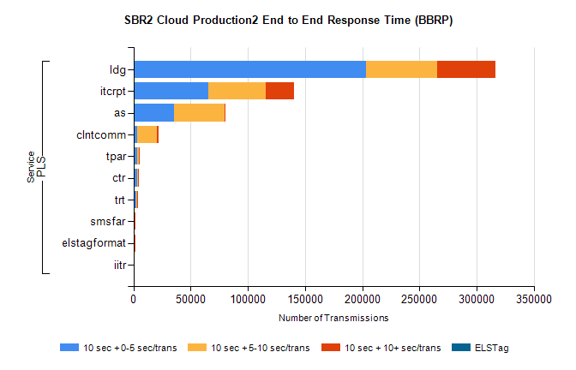
Stream | Service | 10 sec + 0-5 sec /trans | 10 sec + 5-10 sec /trans | 10 sec + >10 sec /trans | Processing Incomplete | ELStag | Total
PLS | ldg | 203097 | 62568 | 50791 | 0 | 0 | 336712
PLS | itcrpt | 65635 | 49929 | 24586 | 0 | 0 | 150333
PLS | as | 35494 | 44108 | 941 | 0 | 0 | 83854
PLS | clntcomm | 3509 | 16818 | 1727 | 0 | 0 | 25456
PLS | tpar | 3498 | 1293 | 42 | 0 | 0 | 4957
PLS | ctr | 3029 | 1061 | 27 | 0 | 0 | 4247
PLS | trt | 2668 | 817 | 28 | 0 | 0 | 3601
PLS | smsfar | 687 | 220 | 6 | 0 | 0 | 934
PLS | elstagformat | 216 | 330 | 2 | 0 | 0 | 567
PLS | iitr | 95 | 20 | 219 | 0 | 0 | 354

SBR1 Production Transactions

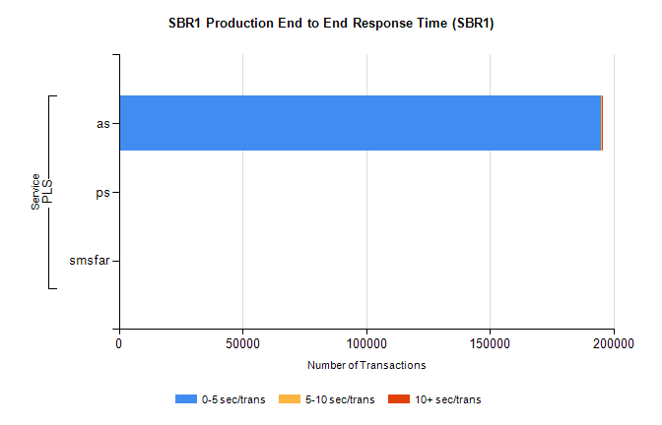
Stream | Service | 0-5 sec/trans | 5-10 sec/trans | 10+ sec/trans | Total | % within 5 sec timing target
PLS | as | 194867 | 358 | 163 | 195388 | 99.7%
PLS | ps | 146 | 103 | 252 | 501 | 29.1%
PLS | smsfar |  | 8 |  | 8 | 0.0%

