Transmission Timings Report Week - 34
17/08/2026 - 23/08/2026

SBR2 Cloud Production2 - Single | Bulk or Batch Requests | (SRP, BBRP & CHiRPP)

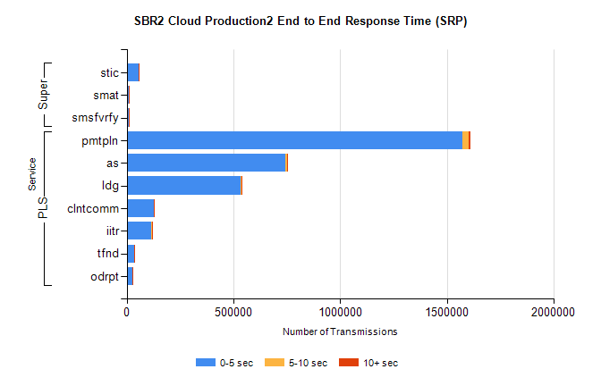
Stream | Service | 0-5 sec | 5-10 sec | >10 sec | Total | % within 5 sec timing target
PLS | pmtpln | 1570050 | 32882 | 6419 | 1609351 | 97.6%
PLS | as | 741446 | 10448 | 1649 | 753543 | 98.4%
PLS | ldg | 533317 | 5455 | 1252 | 540024 | 98.8%
PLS | clntcomm | 125826 | 1801 | 240 | 127867 | 98.4%
PLS | iitr | 116016 | 2175 | 1119 | 119310 | 97.2%
PLS | tfnd | 36043 | 514 | 110 | 36667 | 98.3%
PLS | odrpt | 24429 | 253 | 7 | 24689 | 98.9%
Super | stic | 55972 | 636 | 136 | 56744 | 98.6%
Super | smat | 9826 | 322 | 62 | 10210 | 96.2%
Super | smsfvrfy | 8764 | 244 | 90 | 9098 | 96.3%

SBR2 Cloud Production2 - Single | Bulk or Batch Requests | (SRP, BBRP & CHiRPP)

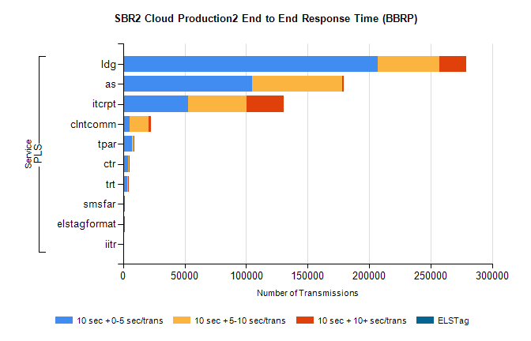
Stream | Service | 10 sec + 0-5 sec /trans | 10 sec + 5-10 sec /trans | 10 sec + >10 sec /trans | Processing Incomplete | ELStag | Total
PLS | ldg | 206881 | 50454 | 21389 | 0 | 0 | 294458
PLS | as | 105147 | 72940 | 1449 | 0 | 0 | 181823
PLS | itcrpt | 53114 | 47477 | 29972 | 0 | 0 | 142023
PLS | clntcomm | 5280 | 15259 | 2307 | 0 | 0 | 26581
PLS | tpar | 7433 | 1231 | 54 | 0 | 0 | 8811
PLS | ctr | 4040 | 513 | 31 | 0 | 0 | 4628
PLS | trt | 3286 | 383 | 21 | 0 | 0 | 3719
PLS | smsfar | 896 | 152 | 9 | 0 | 0 | 1064
PLS | elstagformat | 301 | 390 | 3 | 0 | 0 | 697
PLS | iitr | 90 | 20 | 240 | 0 | 0 | 362

SBR2 Cloud Production2 - Single | Bulk or Batch Requests | (SRP, BBRP & CHiRPP)

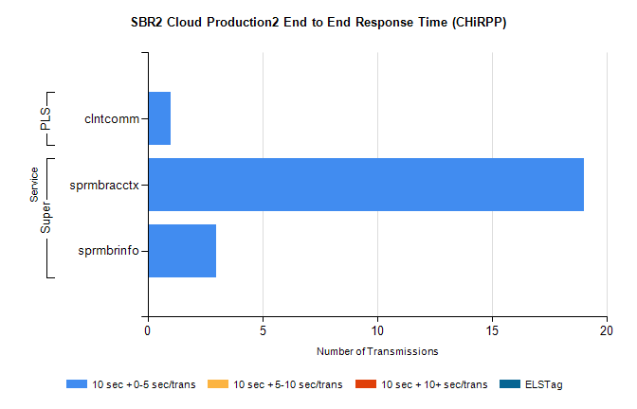
Stream | Service | 10 sec + 0-5 sec /trans | 10 sec + 5-10 sec /trans | 10 sec + >10 sec /trans | Total | % within 5 sec timing target
Super | sprmbracctx | 19 | 0 | 0 | 19 | 100.0%
Super | sprmbrinfo | 3 | 0 | 0 | 3 | 100.0%
PLS | clntcomm | 1 | 0 | 0 | 1 | 100.0%

SBR1 Production Transactions

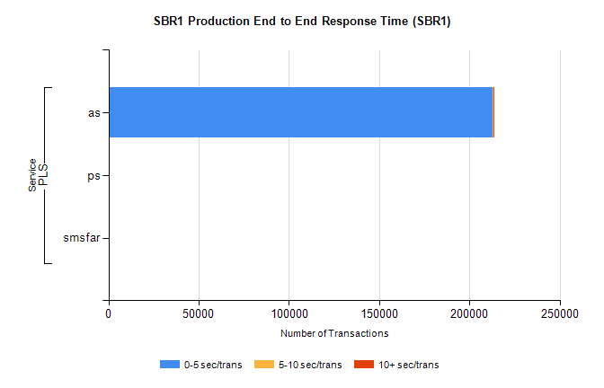
Stream | Service | 0-5 sec/trans | 5-10 sec/trans | 10+ sec/trans | Total | % within 5 sec timing target
PLS | as | 213056 | 280 | 55 | 213391 | 99.8%
PLS | ps | 92 | 63 | 304 | 459 | 20.0%
PLS | smsfar | 2 | 7 |  | 9 | 22.2%

