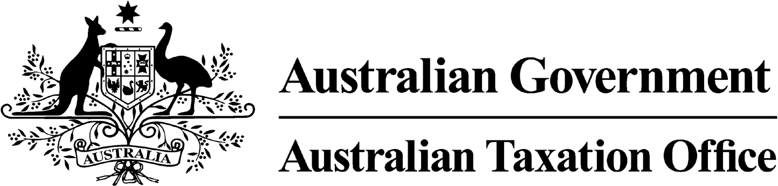
NOTIFICATION | apra-regulated FUNDS | june 2014 | UNCLASSIFIED
Format | Audience | Date | Classification
SUPERSTREAM CONTRIBUTIONS
ALTERNATIVE DATE NOTIFICATION FOR APRA-Regulated FUNDS

PURPOSE
This form is to be completed where a fund (or specific product(s)) will not be able to receive SuperStream compliant contributions transactions by 3 November 2014. All notifications should be completed by an authorised representative of the fund.

For more information, email SuperStreamStandards@ato.gov.au

FUND DETAILS
fund name:
abn:

PRODUCT NAME | USI | REGISTRY SYSTEM | FREQUENCY OF CONTRIBUTIONS | VOLUME OF CONTRIBUTIONS  (per annum) | ALTERNATIVE DATE  * (up to 30 June 2015)

SUMMARY OF IMPLEMENTATION PLAN

This summary should include:
- key milestone dates and delivery phases
- registry systems release dates and dependencies of software solutions
- channels offered to your clients
- how the alternative date will be communicated to your employer clients.

FUND CONTACT DETAILS FOR THIS NOTIFICATION

name:
contact details:

COMPLETED NOTIFICATIONS
Completed notifications are to be sent to SuperStreamStandard@ato.gov.au

